A Review of the Circular Economy state-of-the-practice

Tommaso Calzolari, Andrea Genovese

Sheffield University Management School
University of Sheffield
Conduit Road
Sheffield
S10 1FL, UK

+44(0)1142223347

{t.calzolari, a.genovese}@sheffield.ac.uk

- Introduction – Problem statement
The increasing interest of policy-makers in promoting sustainable development in production and consumption systems has already shaped some directives at the European level, among which the Circular Economy Package (European Commission, 2015) and the Circular Economy Action Plan (European Commission, 2018). Closing the loop of products and material flows is considered a key strategy in many industries, with the aim of decoupling growth from resource consumption. It is also commonly recognised that the development of the Circular Economy concept and its practical applications, at least in the European Union countries, has been at the moment mainly led by practitioners rather than by the scientific community, which has failed to promote a holistic approach to the topic (Korhonen et al., 2018).
The mentioned European directives, coherently to a free-market scenario, openly recognise a very important role for existing organisations which, through bottom-up initiatives, shall drive the realisation of a systemic transition towards the Circular Economy in supply chains. In the European context, several organisations (both SMEs and MNEs) have changed, over the last years, the way they operate, by adopting Circular Economy practices. Such interventions have emphasised product and material reuse and recycle and increased the level of re-generativity of their production and consumption systems, also integrating the use of renewable energy sources throughout supply chains (Genovese et al., 2017).
However, the actual extent to which Circular Economy principles are operationalised at this level has still to be verified and the real impact of legislation changes on companies has yet to be investigated (Stewart & Niero, 2018). This lack of a clear review of the state-of-the-practice outlines the necessity to survey real-world applications in existing organisations in order to improve the level of circularity of supply chains.
This study aims at assessing the Circular Economy state-of-the-practice in a structured way, classifying all the initiatives that can be recognised in the largest European companies. Some attempts have already taken place in this direction, trying to gather and classify existing Circular Economy applications, strategies and challenges regarding many sectors and geographical contexts. Among these initiatives, two notable examples are provided by the Circular Economy Industry Platform and Circle Economy’s Circle Lab. However, these databases are more designed as learning platforms with the objective of sharing existing experiences and best practices, rather than being systematic studies of the real level of transition to the Circular Economy.
For this reason, this study will focus on a globally recognised set of companies, the Global Fortune 500 list, and more specifically on secondary data that can be found in the Corporate Sustainability (CS) reports that are released on a yearly basis by major organisations. By using a structured research method, the aim will be to outline how the 50 biggest European companies in terms of turnover are integrating Circular Economy principles and adopting Circular Economy practices.
On the basis of the identified gaps, the research questions which will be addressed in this study can be summarised as follows:
- RQ1: To what extent do companies introduce CE principles in their CS reports?
- RQ2: What CE practices are implemented by companies?
- RQ3: Has the degree of implementation of CE practices increased in the last three years?
Key findings of the underlying research include an evaluation of the level of implementation of Circular Economy principles and of their link to sustainable development goals. Furthermore, it will be assessed whether general statements contained in annual reports are followed by the implementation of real practices, also surveying which kind of Circular Economy practices are the most popular. An important characteristic of the study is the definition of a period of observation of three years, as an initial attempt to analyse the issue considering also a longitudinal dimension, in order to highlight existing trends inside organisations or sectors.
The remainder of this document is arranged as follows. The next section illustrates the method which will be utilised to tackle the research questions. In Section 3, we highlight the contribution to theory and practice provided by the study, along with some avenues for future research.

- Research Method
The set of European companies which will be employed for this study will be defined on the basis of the Global Fortune 500 list (2019 edition). Such a list collects the top-500 international corporations in terms of turnover generated during the 2018 financial year. In order to address the three research questions, data found in the sourced CS reports will be coded and analysed using a content and a mapping analysis approach, on the model of the similar study conducted by Stewart & Niero (2018), which is focused on the FMCG sector. Concerning RQ2, data found in the CS report will be integrated with further information coming from secondary sources, including press releases, firms’ websites, newspapers articles, along with reports and white papers from consulting companies. Furthermore, a longitudinal approach will be adopted for all the 50 companies of the subset, in order to highlight the evolution of the adoption of Circular Economy practices; as such, CS reports from the 2016, 2017 and 2018 financial years will be surveyed.
The review will consist of three main phases: (i) sample definition, (ii) data collection and (iii) data analysis (see Figure 1). The following sub-paragraphs describe these steps in detail.
2.1 Sample definition
The sample has been defined utilising the Global Fortune 500 list (2019 edition), which collects the Top-500 international corporations in terms of turnover generated during the 2018 year. As the study is part of the EU-funded Horizon 2020 Innovative Training Network ReTraCE, it has been focused on companies within this geographical region, more specifically on the Top-50 European companies in the list. The sample includes a set of companies belonging to different industries and regions in Europe.
The online database Corporate Register has been used to collect the CS Reports referred to the 2016, 2017 and 2018 financial years for all the companies of the subset. In order to access further information that could not be found in such reports, available secondary sources have been considered as well, in the form of press releases, firms’ websites, newspapers articles, white papers from consulting companies and specialized magazines. These sources were accounted for and selected according to their relevance and include the most important international business news sources, including the Economist and Financial Times, and publications from top consulting firms, including Mc Kinsey and Boston Consulting Group.

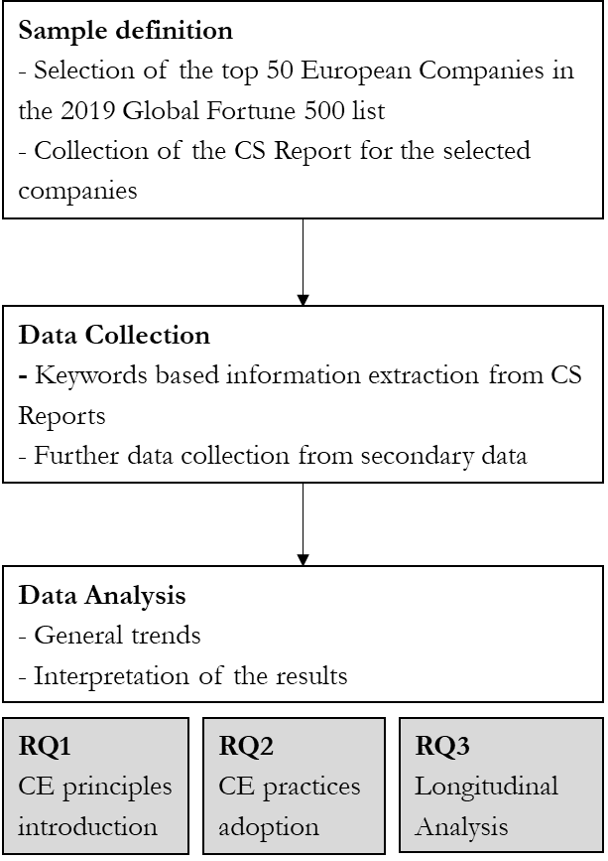
Figure 1 – Flowchart of the methodology

  - Data collection
During this phase, the collected reports are analysed one by one, and the relevant information is extracted and organised in an Excel spreadsheet. In order to identify the relevant parts of the extracts, both some general keyword and also more specific ones have been selected, the former including Circular Economy and Circular Supply Chains or waste and the latter related more specifically to Circular Economy practices which are commonly applied by organisations (such as, for instance, reduce, reuse, recycle, recover, remanufacturing, redesign, design for longevity).
Both quantitative and qualitative measures will be gathered: on one side, the number of times a specific keyword appears in a report, together with measures of density that take into account the length of the report; on the other side, the context in which the main keywords appear and the idea to which they are linked.
A third category of information is related to existing Circular Economy practices and projects. In order to classify these applications we aim to use data coming also from secondary sources to integrate further dimensions into the database, including the type of practice according to the Waste Hierarchy Framework (European Commission, 2014), the impact on performance (if reported), the presence of government incentives in the given geographical context, the industry of implementation, the type of firm, the main drivers of the adoption, the expected results, the type of relationships in the supply chain and the type of ownership.

  - Data analysis
The final step will include a critical analysis of the database, aiming at summarising the relevant findings and highlighting the key messages, finding an answer to the underlined research questions. This phase will also involve a synthetic representation of the quantitative and qualitative data collected.
The final objective will be to recognise existing trends in the way to address Circular Economy principles in stakeholder communication, but also related to the actual implementation of practices. On one side there will be an initial attempt to recognise the industries or the regions that made the most relevant progresses in the concrete transition towards the Circular Economy; on the other side, the most commonly adopted types of practice will be identified, in order to pinpoint which are the dominant implementation approaches and the main drivers for the adoption. Data will be organised through classification dimensions such as the ones reported in Table 1.

Organization name | Company A
Industry | Energy  Petroleum Refining
Country | The Netherlands
Report analysed | Sustainability Report 2018
Year of the Report | 2018
Presence "Circular Economy" in the report | 2
Presence of “R” principles in the report | Yes
Reduce | Yes
Reuse | Yes
Recycle | Yes
Recover | Yes
Existence of CE practices | Yes
Type of practice according to the Waste Hierarchy framework | Recycling
Main motives of adoption | Compliance to regulation
Expected results | /
Registered Impact on performance | 400,000 tonnes waste for recycling or reuse
Presence/Absence of government Incentives | /
Presence/Absence of government Regulation | Presence: A Circular Economy in the Netherlands by 2050
Type of ownership | Private
Level of implementation | mainly general statements; little implementation of recycling practices
Table 1 – Classification dimensions of a CS Report

- Expected results
The promulgation of the mentioned European directives, and the emergence of a heated public debate have sparkled an increased interest of companies in integrating Circular Economy principles in their operations. Such interest should also be followed by a better integration of Circular Economy concepts with their Sustainable Development strategy and especially with the UN framework of Sustainable Development Goals.

It is also expected that this increased interest and attention to the principles goes along with an increased amount of real-world implementation of Circular Economy practices. What should also be determined are the motives of adoption of Circular Economy practices, recognising whether this is a matter of compliance with policy directives or if they are considered as economically attractive initiatives with the potential of reducing costs and gaining new revenues, bringing an impact on the corporate performance.
Another primary focus of the study is to determine the dominant approach in terms of implementation strategies, outlining the types of practice that are mostly adopted by large organisations. This will allow to establish whether such practices just implement the basic elements of the Circular Economy paradigm (such as recycling and/or recovering waste streams generated by the current linear production systems), or, instead, they involve a deep transformation of products and business models in order to reduce waste streams and resource consumption altogether. In other words, if the main focus of such practices is on the symptoms of the established development model, or if it is acting on the root of the problem.
Future steps of this research might also look at extending the study to a broader set of companies or geographical areas.

References
Bjørn, A., Bey, N., Georg, S., Røpke, I., & Hauschild, M. Z. (2017). Is Earth recognized as a finite system in corporate responsibility reporting?. Journal of Cleaner Production, 163, 106-117.
European Commission (2008). Communication from the Commission to the European Parliament, the Council, the European Economic and Social Committee and the Committee of the Regions. on waste and repealing certain Directives.COM (2008) Brussels, Belgium.
European Commission (2014). Communication from the Commission to the European Parliament, the Council, the European Economic and Social Committee and the Committee of the Regions. Towards a circular economy: A zero waste programme for Europe. COM (2014) 398 final. Brussels, Belgium.
European Commission (2015). Communication from the Commission to the European Parliament, the Council, the European Economic and Social Committee and the Committee of the Regions. Closing the loop ‐ An EU action plan for the Circular Economy.COM (2015) 614. Brussels, Belgium.
European Commission (2018). Communication from the Commission to the European Parliament, the Council, the European Economic and Social Committee and the Committee of the Regions. On the implementation of the circular economy package: options to address the interface between chemical, product and waste legislation COM(2018) 32 final. Brussels, Belgium.
Genovese, A., Acquaye, A. A., Figueroa, A., & Koh, S. L. (2017). Sustainable supply chain management and the transition towards a circular economy: Evidence and some applications. Omega, 66, 344-357.
Govindan, K., & Hasanagic, M. (2018). A systematic review on drivers, barriers, and practices towards circular economy: a supply chain perspective. International Journal of Production Research, 56(1-2), 278-311.
Kirchherr, J., Reike, D., & Hekkert, M. (2017). Conceptualizing the circular economy: An analysis of 114 definitions. Resources, Conservation and Recycling, 127, 221-232.
Korhonen, J., Honkasalo, A., & Seppälä, J. (2018). Circular economy: the concept and its limitations. Ecological economics, 143, 37-46.
Korhonen, J., Nuur, C., Feldmann, A., & Birkie, S. E. (2018). Circular economy as an essentially contested concept. Journal of Cleaner Production, 175, 544-552.
Lazarevic, D., & Valve, H. (2017). Narrating expectations for the circular economy: Towards a common and contested European transition. Energy research & social science, 31, 60-69.
MacArthur, E. (2013). Towards the circular economy. Journal of Industrial Ecology, 2, 23-44.
MacArthur, E., Zumwinkel, K., & Stuchtey, M. R. (2015). Growth within: a circular economy vision for a competitive Europe. Ellen MacArthur Foundation.
McDonough, W., & Braungart, M. (2010). Cradle to cradle: Remaking the way we make things. North point press.
Stewart, R., & Niero, M. (2018). Circular economy in corporate sustainability strategies: A review of corporate sustainability reports in the fast‐moving consumer goods sector. Business Strategy and the Environment, 27(7), 1005-1022.

http://www.circulary.eu/project
http://circle-lab.com/knowledge-hub
https://fortune.com/global500/2019
https://sustainabledevelopment.un.org/sdgs

