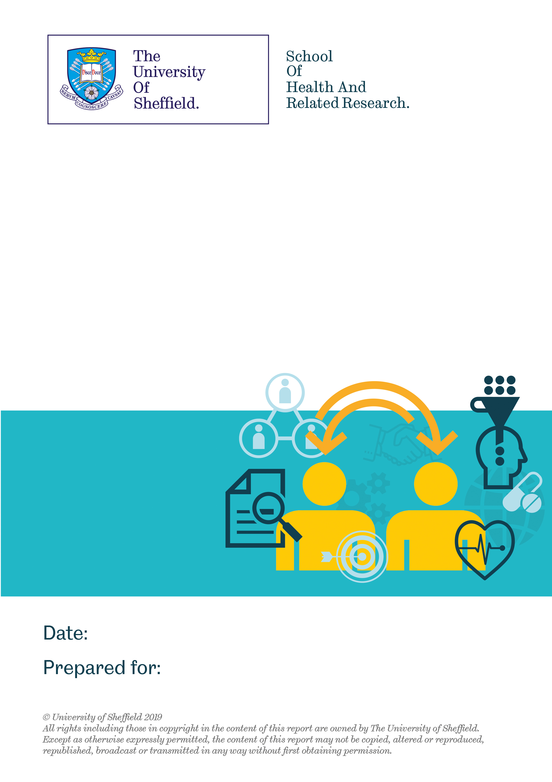

Evaluation of Cruse Bereavement Care’s ‘You Behind the Uniform’
Programme
26th May 2020
Cruse Bereavement Care

Contents
Introduction 4
1. Face-to-face Workshops 4
2. Background of people attending YouBeU 4
2.1 Type of service attendees worked for 4
2.2 The employing organisation of attendees 6
3. Wellbeing of people attending YouBeU 8
4. Opinions on the content of YouBeU 10
4.1 Nature of YouBeU 10
4.2 Relevance of the content of YouBeU 10
5. Relevance to role 12
6. Development of skills and knowledge 13
6.1 Speaking with people 13
6.2 Knowledge of the challenges and issues facing bereaved people following the workshop 13
6.3 How confident do you feel about applying your learning from YouBeU when speaking with others? 14
7. Perceptions of the trainer 14
8. Further statistical analysis 14
9. Free-text comments 15
9.1 Comments about the usefulness and relevance of the training 15
9.2 Knowledgeable trainer 16
9.3 How YouBeU helped develop skills and knowledge of bereavement 17
9.4 How YouBeU could be improved 19
10. YouBeU- E-Learning Course 21
11. Type of emergency service attendees worked for 21
12. The wellbeing of attendees 22
13. Amount willing to pay 23
14. Course content 23
15. Impact on people’s knowledge and skills in relation to bereavement 24
15.1 Confidence in applying your learning when speaking with others? 24
15.2 Knowledge of challenges facing bereaved people 24
16. Relevance to role 24
17. Free-text responses 24
18. Implications for YouBeU (both the workshops and E-learning) 25
19. How YouBeU fits in with the theory of change for the programme 26
20. Summary 26
21. References 27

Table of Tables
Table 1- Type of emergency service attendees worked for 4
Table 2- The organisation attendees worked for 6
Table 3- The wellbeing of people attending YouBeU 9
Table 4- Levels of anxiety amongst attendees (question answered by 429 attendees) 10
Table 5- The emergency services attendees worked for 22
Table 6- Price people would be willing to pay to undertake the YBU E-Learning Course 23

Table of Figures
Figure 1– The type of organisations attendees worked for 5
Figure 2 - Frequency of attendees from each organisation 7
Figure 3 - Levels of wellbeing amongst YouBeU attendees 9
Figure 4 - The relevance of the training 11
Figure 5 - Confidence of attendees in the skills they acquired from the workshop and using these in practice 13

Introduction

This report includes the findings of an evaluation of the You Behind the Uniform (YouBeU) training. The focus of the report is on the experience of people who attended the workshop. Individuals could attend a face-to-face workshop or complete an online programme (E-learning). We firstly explore the feedback from the face-to-face workshop followed by the E-learning. Finally, there are some recommendations for future practice.

The data was collected through people completing an evaluation form after receiving the training. The evaluation form asked people questions about the emergency service they worked for, their wellbeing (the Office for National Statistics, 2018 and their views about the training, including suggestions for improvement. The collected data was anonymised by Cruse before being transferred to the University of Sheffield for analysis in May 2020. Researchers at the University of Sheffield cleaned the data before analysing it using descriptive statistics (Field, 2009). The qualitative data collected through the free-text questions was grouped into categories and analysed thematically.

Face-to-face Workshops

As of 18th March 2020, 546 people had completed the evaluation form following attendance at the workshops. However, the number of people completing each specific question varied and this is detailed in the analysis.

Background of people attending YouBeU

2.1 Type of service attendees worked for (question answered by 546 attendees)

Table 1 - Type of emergency service attendees worked for
Nature of organisation | Number of attendees (n=546) | Percentage (%)
NHS | 366 | 67
Police | 124 | 22.7
Fire | 23 | 4.2
Search and Rescue | 13 | 2.4
Civil Servant | 7 | 1.3
Voluntary | 5 | 0.9
Social work | 5 | 0.9
Other | 3 | 0.5

Figure 1– The type of organisations attendees worked for

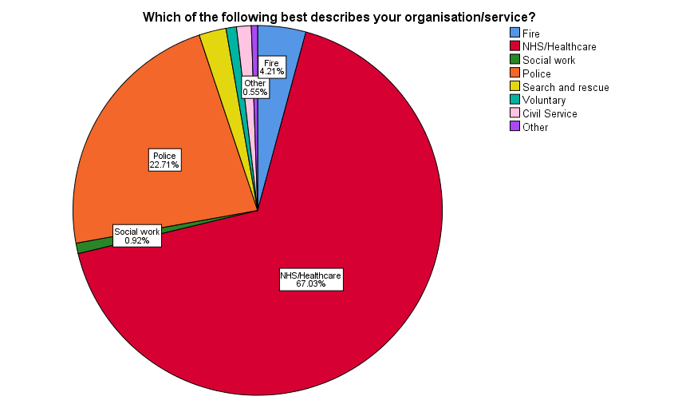

Attendees were from a variety of emergency services (as illustrated in the table and figure above). The majority worked for the NHS such as ambulance services (n=366, 67%). Almost a quarter worked for police services (n=124, 22.7%). Other occupation groups made up less than 5% each of the total attendees. This included fire services, search and rescue teams and civil servants from departments like the Foreign and Commonwealth Office. The range of organisations people work for indicate that YouBeU is appealing to employees from different types of emergency services.

Key learning: To date, attendees have predominately been from the NHS followed by police services. Other attendees came from a range of organisations including the fire service and voluntary organisations. The variety indicates YouBeU is suitable for different types of emergency personnel.

The employing organisation of attendees (question answered by 546 respondents)

Table 2 - The organisation attendees worked for
Name of organisation | Number of attendees (n=546) | Percentage (%)
West Midlands Ambulance Service | 91 | 16.7
South Coast Ambulance Service | 76 | 13.9
South East Coast Ambulance Service | 69 | 12.6
Sussex Police | 41 | 7.5
London Ambulance | 38 | 7.1
NHS Dumfries | 30 | 5.5
Greater Manchester Police | 27 | 4.9
Metropolitan Police | 25 | 4.6
Hampshire Fire & Rescue | 23 | 4.2
Devon Air Ambulance | 21 | 3.8
Health & Safety Investigation Board | 18 | 3.3
Police Service of Northern Ireland | 12 | 2.2
Midlands Air Ambulance | 11 | 2.0
Police Scotland | 10 | 1.8
Northern Ireland Fire and Rescue Service | 10 | 1.8
East England Ambulance Service | 10 | 1.8
Suffolk Police | 8 | 1.5
Bedfordshire Police | 6 | 1.1
Foreign Commonwealth Office | 6 | 1.1
Norfolk Police | 5 | 0.9
East Midlands Ambulance Service | 3 | 0.5
Warwickshire Search and Rescue | 2 | 0.4
Fire Scotland | 1 | 0.2
West Mercia Search and Rescue | 1 | 0.2
Marie Curie | 1 | 0.2
University of Canterbury | 1 | 0.2

Figure 2 - Frequency of attendees from each organisation
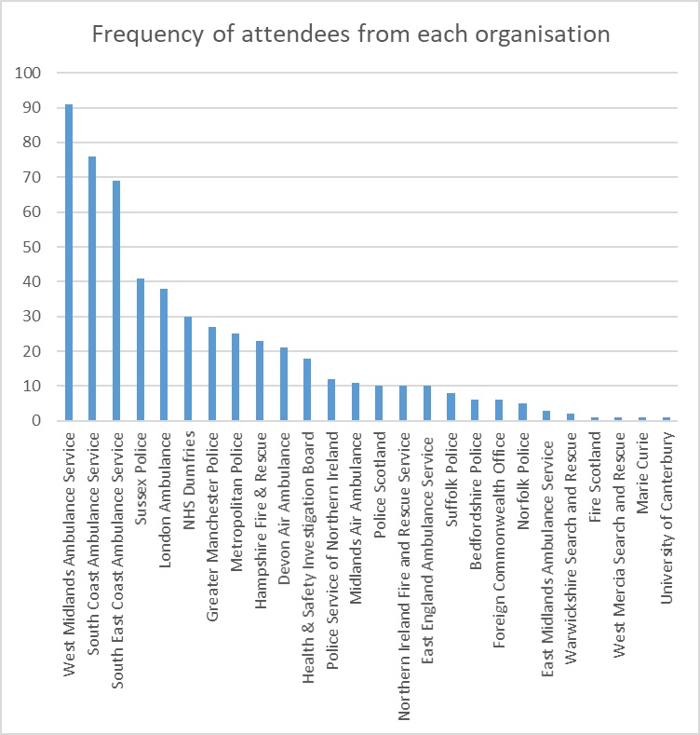

Attendees came from 26 different organisations, although this ranged from 91 attendees from one service to 1 person from other organisations (detailed in the table and figure above). Three ambulance services were the organisations that had the most attendees. Over 60 employees from each ambulance service attended YouBeU. Other organisations included different police, air ambulance and search and rescue teams. Differing levels of attendance raises issues about whether Cruse want to target the course at specific organisations or run more general courses where people from a number of services attend. People worked for organisations based through the United Kingdom including Scotland, Northern Ireland and different regions of England. The range of organisations indicates that Cruse has managed to build up good relationships with a range of emergency services in different geographic locations who are interested in having their employees attend YouBeU.

Summary: People attended YouBeU from a range of organisations, demonstrating Cruse’ success at developing relationships with different types of emergency services.

Wellbeing of people attending YouBeU (question answered by 434 attendees)

Attendees were asked about their wellbeing through using the Office for National Statistics (ONS) 4 Wellbeing questions. These questions ask people about their life satisfaction, whether a person feels what they are doing in their life is worthwhile and how happy they are feeling. Respondents rate themselves on a scale between 1-10, with a higher score indicating greater wellbeing. People scoring 0-4 is classed as low, 5-6 is medium, 7-8 high and 9-10 is very high (Office for National Statistics, 2018). The UK national mean is from has the Office for National Statistics annual update (2019). The wellbeing of attendees is explored below (Table 3, Figure 3).

Generally, attendees had a high or very high level of life satisfaction. The mean life satisfaction of attendees would also be considered high (7.3). This was slightly lower but is fairly comparable to the UK population mean of 7.7. Over three quarters of attendees classed themselves as having high or very high life satisfaction (n=330, 76%). Only 5% of attendees were categorised as having a low level of life satisfaction (n=22, 5.1%).

On average, attendees had a high level of feeling what they do in their life is worthwhile. The mean was 7.6, only slightly lower than the UK population mean of 7.8. Over three quarters of attendees had a high or very high sense that the things they do in their life are worthwhile (n=338, 77.8%). A small number of attendees were classed as having a low sense of what they were doing in their life was worthwhile (n=18, 4.1%).

On average attendees had a high level of happiness (7.1). This again was slightly lower, but fairly comparable to the UK population mean of 7.6. Attendees appeared to have a lower score of happiness than they did for the other wellbeing questions. For example, 67.1% (n=291) people were categorised as having high or very high levels of happiness, compared to over 75% for the other two wellbeing questions. There was also a slightly higher percentage of people categorising themselves as having a low level of happiness (n=32, 7.4%).

Table 3 - The wellbeing of people attending YouBeU
Level of wellbeing | Overall, how satisfied are you with your life nowadays?  n=434 (%) | Overall, to what extent do you feel that the things you do in your life are worthwhile? n=434 (%) | Overall, how happy did you feel yesterday?  n=434 (%)
Low (0-4) | 22 (5.1) | 18 (4.1) | 32 (7.4)
Medium (5-6) | 82 (18.9) | 78 (18.1) | 111 (25.5)
High (7-8) | 243 (56.0) | 218 (50.2) | 193 (44.5)
Very high (9-10) | 87 (20) | 120(27.6) | 98 (22.6)
Mean amongst attendees: | 7.3 (SD: 1.6) | 7.6 (SD:1.6) | 7.1 (SD:1.8)

Figure 3 - Levels of wellbeing amongst YouBeU attendees
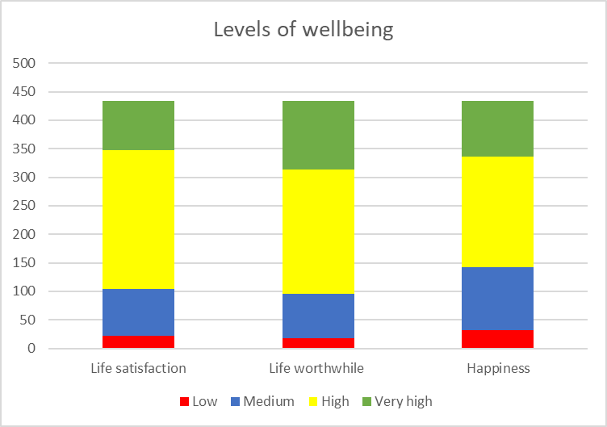

Attendees were also asked about how anxious they felt (Table 4). Again attendees were asked to rate their anxiety between 1-10, but the scores are reversed with lower scores indicating a lower level of anxiety. This question was answered by 350 respondents. Almost half of attendees had a very low or low level of anxiety (n= 205, 47.85%). However, there was also over a quarter of attendees who consider themselves to have a high level of anxiety (n=132, 30.8%). The mean level of anxiety amongst attendees was greater than the UK population mean. The UK population mean is 2.97 (a low level of anxiety), whereas the mean amongst attendees was 4.1, which is a medium level of anxiety.

Summary: Generally, attendees had a high level of wellbeing, which was similar to the UK population mean. However collectively, attendees appeared to have a higher level of anxiety than the UK population mean.

Table 4 - Levels of anxiety amongst attendees (question answered by 429 attendees)
Level of anxiety | Overall, how anxious did you feel yesterday? (n=429)
Very Low (1) | 77 (17.9)
Low (2-3) | 128 (29.8)
Medium (4-5) | 92 (21.4)
High (6-10) | 132(30.8)
Mean: | 4.1 (SD: 2.4)

Opinions on the content of YouBeU

4.1 Nature of YouBeU (question answered by 542 attendees)

The vast majority of people attended a full day session (n-442, 81.5%), with the remaining 18.5% (n=100) attending a half day workshop. In the feedback, there was comments from a small number of people wishing the training had been a full day or vice versa. It may be useful for Cruse to reflect on the difference between a half and full day and consider the different target audiences for these.

Summary: The majority of respondents attended a full day workshop. Most people appeared satisfied with the length irrespective of whether they attended a full or half day.

4.2 Relevance of the content of YouBeU (question answered by 471 attendees)

Attendees were asked to rate the relevance of elements of YouBeU out of 5, with a higher number indicates relevancy. The majority of responders found the content on models of bereavement, what to say/not to say and self-care and resilience highly relevant. Further details are given below but the positive feedback indicates that the content of the training is suitable for emergency service personnel. Figure 4 summarises how generally attendees felt the content of the training was relevant to them and their role.

Figure 4 - The relevance of the training

Relevance of learning about the models of bereavement
Generally, attendees found it very relevant to learn about the models of bereavement. Over half of attendees rated this element of YouBeU a 5/5 (n=266, 56.5%). A further 140 attendees considered the relevance to be 4/5, again indicating they found the learning on models of bereavement useful (29.7%). Less than 5% of attendees did not find the learning on models of bereavement useful (n=15, 3.2%). None of these respondents had any specific feedback about why they did not find it relevant.

Relevance of learning about what to say/not to say
Attendees found it useful learning about what to say/not to say to someone experiencing bereavement. The majority of attendees rated this element of YouBeU a 5/5 (n=337, 71.5%). A further 82 attendees rated the what to say/not section a 4 (n=100, 21.2%). There were 9 people (1.9%) who did not find the what to say/not to say element relevant. Their main reason was because they wanted more content about what to say to someone to break the news of a death and what to say in the immediate hours following a bereavement.

Relevance of learning about self-care and resilience
The majority of attendees found the content on self-care and resilience relevant. Two-thirds of attendees (n=314, 66.7%) rated this element a 5 out of 5, indicating they found it very useful and a further 117 attendees scored it 4 out of 5 (24.8%). Only 9 (1.9%) people rated the section on self-care and resilience as not useful. Given the positive feedback, it is recommended that Cruse continue to deliver this part of YouBeU.

Amongst responders, there were only 8 people who consistently did not feel the different elements of the workshop were relevant. Interestingly only 3 of these then did not feel the training was relevant to their role. Given the small numbers, it demonstrates that the vast majority of attendees felt YouBeU was suitable.

Summary: Attendees found the content of YouBeU to be highly relevant and it is recommended Cruse continue to deliver these parts of YouBeU. However, there appears some scope for including information on breaking the news of a death to someone and supporting people in the immediate aftermath of a bereavement.

Relevance to role (question answered by 467 attendees)

Cruse appear to be delivering YouBeU to the appropriate people. Almost 90% of attendees found the training very relevant to their role (n=414, 88.7%). Less than 10% scored the training as 3 of 5, indicating they found the training as somewhat relevant to their role (n= 40, 8.6%). Only a small number of attendees did not find the workshop relevant to their role (n=13, 2.7%). These people wanted further information about how to break the news of a death and supporting a person in the immediate aftermath of a bereavement. These issues appear to be important elements to add into YouBeU.

Key learning: Cruse appear to be delivering YouBeU to the relevant personnel within the emergency services. However, Cruse may want to consider incorporating more information into YouBeU about breaking the news of a death and supporting people in the immediate aftermath of a bereavement.

Development of skills and knowledge

Attendees were asked about whether they felt their skills and knowledge in respect of bereavement had increased through attending the workshop, and generally people felt they had benefitted from attending. The responses are summarised in Figure 5.

Figure 5 - Confidence of attendees in the skills they acquired from the workshop and using these in practice

6.1 Speaking with people (question answered by 468 attendees)

YouBeU increased attendees’ confidence with speaking with people. Over 90% of attendees (n=438, 93.6%) felt the workshop increased their confidence with speaking with people. There were only 3 people who did not feel YouBeU helped them in this regard. This was because they wanted further information about breaking the news of a death and supporting people in the immediate aftermath of a bereavement.

Summary: Attendees found YouBeU helped to improve their confidence with speaking with people.

6.2 Knowledge of the challenges and issues facing bereaved people following the workshop (question answered by 468 attendees)

The majority of attendees felt they became very knowledgeable about the issues facing people experiencing bereavement following attendance at the workshop (n=427, 91.2%). There were 5 attendees who did not feel they gained knowledge on the challenges facing people. Only one person gave feedback about why they gave a low score and their feedback was they felt YouBeU confirmed rather than developed their knowledge.

Summary: Attendees felt YouBeU helped them to develop a greater understanding of the challenges and issues facing bereaved people.

6.3 How confident do you feel about applying your learning from YouBeU when speaking with others? (question answered by 468 attendees)

Over 90% (n=425, 90.8%) of attendees felt very skilled in applying their learning from YouBeU when speaking to others. Only 6 people (1.3%) felt they were not skilled in applying their learning. One person gave feedback explaining that they wanted more content about delivering the news of a death and supporting people in the immediate period after a bereavement.

Summary: It appears that YouBeU is helping people within their employment and life generally because the majority of attendees felt confident that they could apply their learning when speaking with others.

Perceptions of the trainer (question answered by 468 attendees)

The trainers were well received by attendees. Almost all attendees rated the trainers as highly skilled (97.2%, n=455) rated the trainers as highly skilled. Ten people (2.1%) scored their trainer a 3 out of 5, indicating they considered the trainer neither skilled nor not skilled. Only 3 people rated the trainer as unskilled, scoring them a 2. Unfortunately, these individuals did not provide further information on why they were dissatisfied with the trainer. The positive feedback for the trainers, and that this appears consistently irrespective of which trainer delivered YouBeU indicates that Cruse are using appropriate trainers. Ideally, Cruse should continue to use the same trainers to deliver YouBeU.

Summary: The trainers were rated as exceptional by almost all of the attendees and should continue to be used to deliver YouBeU.

Further statistical analysis

As the course feedback has been exceptionally positive, it was decided not to undertake further analysis exploring about whether there any were differences in opinions about the course between different groups of emergency service personnel or people who attended the one/half day workshops. This is because there is not sufficient differences in responses to run meaningful statistical tests.

Free-text comments

Respondents were invited to provide additional free text comments about the relevance of the workshop, how it developed their skills and what improvements could be made. 297 attendees provided comments. This section of the report considers that feedback.

9.1 Comments about the usefulness and relevance of the training

This question prompted a great deal of positive feedback with respondents reporting how YouBeU was very beneficial. There were several mentions of how useful it was to learn about the models of bereavement. Respondents appreciated the fact the trainers were very knowledgeable and believed YouBeU should be rolled out more widely, with some attendees suggesting training should be mandatory. YouBeU had the additional benefit of being relevant to the individual both in and out of the work environment, with one participant stating that the course was “100% relevant to me as a human being”.

A very beneficial course
Respondents felt YouBeU was a very beneficial, appropriate, interesting course, which was well presented and exceptionally useful. The training was enjoyable, informative, thought provoking, relevant and something that would help them in their future practice:

“It was the most worthwhile course I have been on this year. Thank you”

“The course was very informative and useful. Good discussions of others’ experiences which were helpful”

“Lots of opportunities for conversation, didn't feel like a classroom which was good. Lots of different organisations coming together to have conversations and support each other”

I was very surprised at how relevant this training was and believe the trainers approach was spot on”

Effective use of the models of bereavement and grief
Several attendees appreciated being provided with an overview and awareness of the various models of bereavement:

“The models were helpful to help explain some emotions being felt. It also opened my eyes to how symptoms of loss and bereavement can be physical in other ways”

“The models of bereavement and grief were interesting and useful when thinking about assessing and working with bereaved/grieving people. It also helped put perspective on different types of grief, not just death”

“It helped reaffirm the stages of bereavement one must go through to fully progress through the grief process”

Should be mandatory and offered to all front line staff
There were many comments relating to how YouBeU should be mandatory and rolled out to all front-line staff:

“There is a lack of training and development given to police family liaison officers and this training should be mandatory for all officers taking on this role. I found it vitally helpful”

“Should be made more widely available for all staff”

“Excellent. Should be delivered to all staff”

Knowledge gained related to both work and their personal situation
Some felt YouBeU was useful not only within the work environment, but was also of benefit to anyone who wants to better understand themselves and the people around them, which includes supporting colleagues and caring for friends and family:

“Very relevant to anyone who may suffer a bereavement or may be helping a bereaved customer or relative”

“I feel like I gained a life skill I can use in and outside of work”

“It really helped look at my ability to remain resilient at times of severe stress and anxiety”

“Very good course. Very beneficial in my line of work as a paramedic also as someone who is going through a bereavement. It was beneficial to further my own knowledge and also to help me deal with ongoing problems”

“It was very informative, certainly about the self care, makes you stop and pay attention to warning signs that you may not recognise as warning signs”

“Very useful. I wish I had known some of the signs years ago as I was diagnosed with PTSD last year”

9.2 Knowledgeable trainer

There were many comments relating to the excellent, engaging and professional trainers. Course leaders were praised for their knowledge of the broad range of subject areas covered and how they developed the course to suit the needs of the class:

“Really valuable session, handled sensitively and compassionately by the trainer on the day. So much so that people felt comfortable enough to open up and share personal situations of grief and loss”

“The tutor was excellent, extremely knowledgeable in her subject, her delivery was outstanding and I wanted to learn more”

“What a fantastically delivered course with such relevant content and practical advice for dealing with such a sensitive issue. Trainer was brilliant with a great style and her experience was pivotal to the discussions”

Many respondents mentioned the trainer by name and in glowing terms:

“Jonathan was brilliant, very knowledgeable, approachable and friendly”

“In three hours Nigel has managed to consolidate and refine some of the knowledge that I have taken 3yrs to accrue - well done!”

“The instructor Sue was very approachable, friendly and knowledgeable”

“It was an excellent day. The facilitator, Delphi, was very knowledgeable and she was excellent”

“Terry was brilliant at explaining all things and telling us key information”

9.3 How YouBeU helped develop skills and knowledge of bereavement

YouBeU provided both new knowledge and skills, but was also considered as a refresher for some. YouBeU increased respondents’ communication skills and confidence in difficult situations, whilst also providing affirmation they were doing the ‘right thing’.

Provided new knowledge and skills
For some, YouBeU was the first bereavement training they had ever received, and many reported it had had enabled them to gain a lot of new knowledge. Individual responses included: conceptualising grief and bereavement in contexts other than death, having a better understanding of the issues people experience, how best to assist those who need support or help and how to deal with someone’s bereavement:

“It helped me gain a deeper understanding into what bereavement is and how our patients go through it. I didn’t understand it fully before as I have never helped a patient in the initial process at the time of an incident. I feel now that I have skills to be able to support a patient more effectively”

“I think the reminder that you can feel bereaved in any circumstance for a multitude of different reasons was a good refresher. It also encouraged me to internally challenge my own accidental conscience bias. Also a reminder to challenge society and its pressures on people”

There were several respondents who had never received any previous bereavement training so the workshop provided an excellent insight, giving them confidence and a platform to build on:

“This is the first time I had received any training relating to bereavement but have been dealing with it for the last 37 years”

“I have had no previous bereavement training and therefore the whole day was very helpful and relevant”

“No formal training or guidance really so after 15 years in the police this was such a worthwhile training input. Walking away with additional confidence and knowledge”

Used as a ‘refresher’
For a number of people, YouBeU was described as a ‘refresher’ to update and support current knowledge, reinforce good practice, provide new ways to deal with challenging situations and consolidate previous learning:

“While I have some knowledge in this area, it was great to have this strengthened, with additional tools and techniques to add to my own toolkit as well as sharing with my team”

Increased communication skills
Attendees felt YouBeU provided ways to improve their communication, listening and conversation skills including an awareness of the importance of body language and how these skills help you understand and be able to make a difference to people who have suffered a bereavement:

“It highlighted my terrible habit of trying to empathise by saying things like "I know how you feel...when my (parent etc) died...". People do not need to hear about my experiences. It should be about them, not me”

“Taught me to keep the focus on the bereaved person, and not to apply one’s own experiences / thoughts / feelings to someone else’s situation”

Increased confidence in difficult situations
Many believed YouBeU would make them more confident when approaching difficult situations and they had been provided with appropriate training on ‘what to and what not to say’ so they were more able to speak to grieving relatives and less likely to shy away from people who may be struggling:

“Before this session, I was concerned that I would say the wrong thing and leave a bad long lasting memory for families. I now feel confident to approach those affected and will able to support them in their difficult time”

“I think concentrating on what to/what not to say was useful as there is nothing worse than saying the wrong thing”

Provided affirmation that they were doing the ‘right thing’
YouBeU provided staff with validation and reassurance that they were doing the ‘right thing’ and they had been approaching bereavement in an appropriate manner:

“It helped provide reassurance and confidence in the skills I already have. It allowed for reflection of current practice”

“It made me realise I had a good knowledge base and it reaffirmed that I am
doing ok”

9.4 How YouBeU could be improved

Although overall YouBeU was very positively received by attendees, this section asked attendees to comment on how the training could be improved. They reported that a tailored course to their specific role would be useful, with many saying they would like a longer workshop with additional training across a number of areas. The opportunity for more practical, hands on, experience as part of the course would be widely welcomed.

More tailored
Although a strength of the training was described by one as being useful to work with a trainer and colleagues from across services (cross fertilisation), a number suggested that a more tailored approach for different groups of professionals, would be beneficial:

“A special tailored day for health care professionals would be great”

“Specifically for ambulance service staff would have been useful to have more in-depth discussion/teaching on what to say/do in the immediate aftermath of a death and breaking the initial bad news - in particular when there are young children on scene or when people on scene are extremely emotional/angry and how best to communicate with these groups”

“Make it more relevant to police as we are normally on scene with family when the ambulance has left”

Increase the duration
Some felt the workshop should be longer and include more detailed information such as advanced communication skills, updates on latest evidence, more detail on bereavement models, suicide bereavement (especially within the work place), guidance on how different cultures perceive bereavement and a greater opportunity to discuss how staff can manage their own mental health (cathartic elements). It was suggested that an additional day would be useful and the training could provide more opportunities for discussion and time for sharing experiences as it was acknowledged that there was a wealth of experience within the room. Another suggested that pre course reading would be a welcomed addition:

“The course is too short for the subject. A longer course will give time for discussion”

“I would like more training like this so we could look at some subjects more
in depth”

The following, more specific topics were highlighted as potentially relevant should the course be expanded:

Information on the death of a child and on supporting children experiencing bereavement

“The workshop was overall really great however I do think that there could have been more on the subject of dealing and talking with children instead of just touching on the subject”

“It would also have been beneficial to have an input on talking to young children about death and perhaps any questions that people may ask you and what the best responses are”

Breaking the news of a death, supporting someone in the immediate hours after a bereavement and supporting those with a terminal illness and their families
A number of respondents reported that they would like more training on delivering the news of a death, supporting someone in the immediate hours after a bereavement and specific information on how to support the families of those dealing with a terminal illness:

“Specific delivery of bad news and support at time of death”

“I would have liked a bit more information on how to deal with terminally ill people and their families that will be facing bereavement in the near future”

Include opportunities for practical work
Respondents would also like the course to be undertaken within a more experiential practice based learning approach with real life examples from the different agencies, a focus on group work, small group discussions and opportunities to get involved:

“I felt as if the first part of the day went on too long with the ice breakers about what emotions are and felt the second half of the day discussing case studies and practical scenarios and what to and not say were more useful”

Practical examples and role play would be welcomed, for example how to address people or dealing with awkward situations. Videos could be utilised and a greater emphasis placed on case studies/ scenarios to put in to practice what has been learnt. This would ensure the training is more interactive:

“Role play on 'breaking bad news' would be handy. Although many have been doing this for some years, we could always learn a different, more effective way”

“If we had more time to get hands on, practice, and simulate different situations in the form of role play”

“Work in groups with given scenarios and work through them as a class how you would deal with the situation”

YouBeU- E-Learning Course

Along with the face-to-face workshops there was an option for people to undertake an online version of YouBeU (E-learning). As of January 2020, 26 people had completed the evaluation form following accessing YouBeU online.

Type of emergency service attendees worked for (question answered by 26 people)

People accessing the E-learning came from a range of professions including the NHS, police and voluntary sector. There were a number of chaplains who accessed the course who worked for the police but they have been categorised separately to illustrate their different role. Other organisations included healthcare education and a professional body. Almost half of attendees came from NHS healthcare organisations (n=11, 42.3%). This was followed by a quarter being chaplains (n=6, 23.1%) linked to emergency services such as the British Transport Police. Chaplains did not attend the face-to-face training but appeared to find the E-learning useful so may be a potential professional group to recruit to the workshops. The feedback was generally exceptionally positive indicating the E-learning appeared useful irrespective of the specific emergency service attendees worked for.

Table 5 - The emergency services attendees worked for
Type of organisation | Number (n=26) | Percentage (%)
NHS Healthcare | 11 | 42.3
Chaplain | 6 | 23.1
Police | 2 | 7.7
Military | 2 | 7.7
Voluntary sector | 2 | 7.7
Other | 3 | 11.5

Summary: The E-learning has been accessed by people from a variety of emergency services and other types of organisations. All appear to have found the course useful and relevant so Cruse are targeting the E-learning appropriately.

The wellbeing of attendees (question answered by 14 people)

As explained earlier in the report, responders were asked to answer the ONS-4 questions about their wellbeing. Generally, the wellbeing of the people accessing the E-learning was similar to those attending the workshops and the UK population average.

All responders experienced at least a medium or high level of satisfaction with their life. The mean response was 7.5, Indicating people generally had a high level of satisfaction with their life. This was similar but ever so slightly lower than the UK population mean of 7.7.

Generally, people had a high sense that what they did with their time was worthwhile. The mean was 7.8, which is equivalent to the UK population mean. All respondents experienced a medium or high sense that what they did with their time was worthwhile.

The mean happiness score amongst respondents was 7.2. This is classed as a high level of happiness. The score is similar to that of the UK population mean of 7.6. Whilst the mean was a high level of happiness, there were two individuals who had a low level of happiness.

People accessing the E-learning experienced different levels of anxiety, with some people not feeling anxious at all whereas others were feeling very anxious. The mean anxiety score was 3.4, indicating that generally people were experiencing a low level of anxiety. The mean anxiety score was slightly higher than the UK population mean of 2.97.

Amount willing to pay (question answered by 26 people)

Respondents were asked how much they would be willing to pay to access the E-learning. The range was between £5-£50, with the mean being £20.60 (SD: £14.60). There was considerable variation in the amount people would be willing to pay, with no clear consensus about whether the course should be around £10 or rather the £20-£25 mark.

Table 6 - Price people would be willing to pay to undertake the YBU E-Learning Course
Price people were willing to pay | Number of respondents (n=26) | Percentage
£5 | 4 | 15.4
£10 | 6 | 23.2
£15 | 3 | 11.5
£20 | 5 | 19.2
£25 | 3 | 11.5
£30 | 1 | 3.8
£50 | 4 | 15.4

Summary: Whilst people would be willing to pay for the YouBeU, people varied in the amount they felt was appropriate. Based on the current feedback, £20 is the average price however the range of responses means it’s difficult to identify an acceptable price point.

Course content (questions answered by 14 people)

Respondents were asked to rate out of 5 how relevant they found elements of YouBeU. This included the training on models of bereavement, what to say and self-care and resilience. In relation to the content on models of bereavement and self-care and resilience, all respondents rated the content as being relevant (giving a score of 4 or 5). In terms of what to Say/not to say, 13 of the 14 people rated the content highly relevant. There was one person who felt the content was neither relevant nor irrelevant.

Summary: Attendees the content of YouBeU highly relevant and thus Cruse should continue to deliver these elements of the E-learning.

Impact on people’s knowledge and skills in relation to bereavement (question answered by 14 people)

15.1 Confidence in applying your learning when speaking with others?

All of the attendees felt confident in applying the learning when speaking with others.

15.2 Knowledge of challenges facing bereaved people

All but one respondent felt YouBeU helped them understand the challenges faced by bereaved people.

Relevance to role (question answered by 14 people)

Respondents felt the course was very applicable to their role, with all but one person feeling it was relevant. This indicates that Cruse has shaped YouBeU to meet the needs of emergency personnel.

Summary: YouBeU is being delivered to appropriate emergency service personnel because respondents found the learning relevant to their role.

Free-text responses

Respondents were given the opportunity to feedback about the relevancy of the E-learning, whether accessing the learning helped developed their skills and how the training could be improved. There were only a small number of comments, but they were useful in terms of understanding peoples’ views.

Feedback about the relevancy of the E-learning
Seven people provided comments about the relevancy of the E-learning with feedback focusing on how the course fitted with attending the workshops and positive feedback about the relevance of YouBeU.

The relationship between the workshops and E-learning
Two people explained they had already attended the workshops- one person felt that the E-learning helped reinforce their learning. However, the other respondent felt they had already covered the content within the workshop so the E-learning was not useful for them personally. This mixed feedback raises questions about whether the E-learning is useful or not for people who attended the workshops. This is interesting as some feedback from the workshops was about wanting online materials to provide reminders about the learning. Given this, it may be useful to Cruse to explore the feasibility of having an online refresher course to supplement the workshop and target the E-learning at people who have not attended a workshop.

Positive feedback about the relevance of YouBeU to emergency personnel
Other feedback related to people praising the relevancy of YouBeU to emergency personnel. It was apparent that the training being tailored to the emergency services was valued by attendees. For example one person felt:

“The advice to stand alongside someone in their pain, rather than try to "Fix things", is the best advice for caring that I have come across.”

Feedback about how the E-learning helped people to develop their skills
Five comments were provided about how the E-Learning helped people to develop their skills. One person commented that having the E-Learning option was more feasible for them than trying to attend workshop. Another person commented that YouBeU was especially helpful in terms of understanding and supporting people experiencing.

Suggestions for improving the E-learning
Two people provided suggestions for improving the E-learning. One comment related to having more videos to help maintain concentration. The other suggestion related to improving the ending of the course such as having a recap at the end.

Implications for YouBeU (both the workshops and E-learning)

Positives
- YouBeU appears to be exceptionally well-received by attendees.
- People from a range of emergency services and specific organisations attended the training and found it useful, indicting it is appropriate for many types of emergency services personnel.
- The content was considered relevant and useful.
- The trainers were considered as highly skilled.
- YouBeU helped people improve their knowledge, confidence and capability in supporting people experiencing bereavement.
- Attendees felt YouBeU was unique and they had never received training on bereavement. Some people even felt YouBeU should be mandatory and part of induction training.
- The positive feedback indicates that Cruse could consider further delivery of the course through charging to deliver the course to organisations.

Issues to reflect on
- Cruse need to consider the different functions of the workshops and E-learning to decide how they fit together within a training package.
- A variety of emergency personnel found YouBeU useful and Cruse may want to widen attendance from predominately the ambulance service.
- Some people suggested the training may be best targeted at newer members of staff (whilst acknowledging that experienced workers have never received training on bereavement).
- There are additional factors which people would like information on including:
- Supporting someone who has experienced the death of a child
- Supporting children experiencing bereavement
- Breaking the news of a death
- Supporting someone in the immediate aftermath of a bereavement
- There appeared some need for having more practical elements within the course such as role play.
- YouBeU could be specifically tailored for certain types of emergency personnel

How YouBeU fits in with the theory of change for the programme

The feedback indicates delivery of YouBeU fits in with the theory of change developed by Cruse. Attendees reported having a greater understanding of bereavement and feeling more confident to speak with people about bereavement which reflects the short-term outcomes of the training. Whilst the evaluation could not identify whether YouBeU improved the impact of unprocessed grief on people, there is suggestive evidence that attendees feel they could better support colleagues experiencing grief but also understand better about processing their own grief.

Summary

YouBeU was well received by people in the emergency services. Attendees from different types of emergency services throughout the United Kingdom found the course exceptionally useful in terms of improving their knowledge, skills and confidence when supporting someone experiencing bereavement. The content and trainers appear to be suitable, although there are additional issues which could be incorporated into the training. Cruse need to consider the relationship between the workshop and E-learning versions of the course such as who should attend which. Attendees did not feel there were equivalent courses available. Given both the positive feedback and the uniqueness of the course, it appears there is evidence to continue delivery of the course, either through seeking further funding or charging for delivery.

References

Field, A. (2009). Discovering statistics using SPSS (3rd ed.). Thousand Oaks, CA: Sage

Office for National Statistics. (2018). Personal Wellbeing in the UK (online). Available from: https://www.ons.gov.uk/peoplepopulationandcommunity/wellbeing/methodologies/personalwellbeingintheukqmi. Accessed: 23/12/2019.

Office for National Statistics. (2019). UK Population Means (online). Available from: https://www.ons.gov.uk/peoplepopulationandcommunity/wellbeing/bulletins/personalandeconomicwellbeingintheuk/november2019#personal-well-being. Accessed 23/12/2019.

