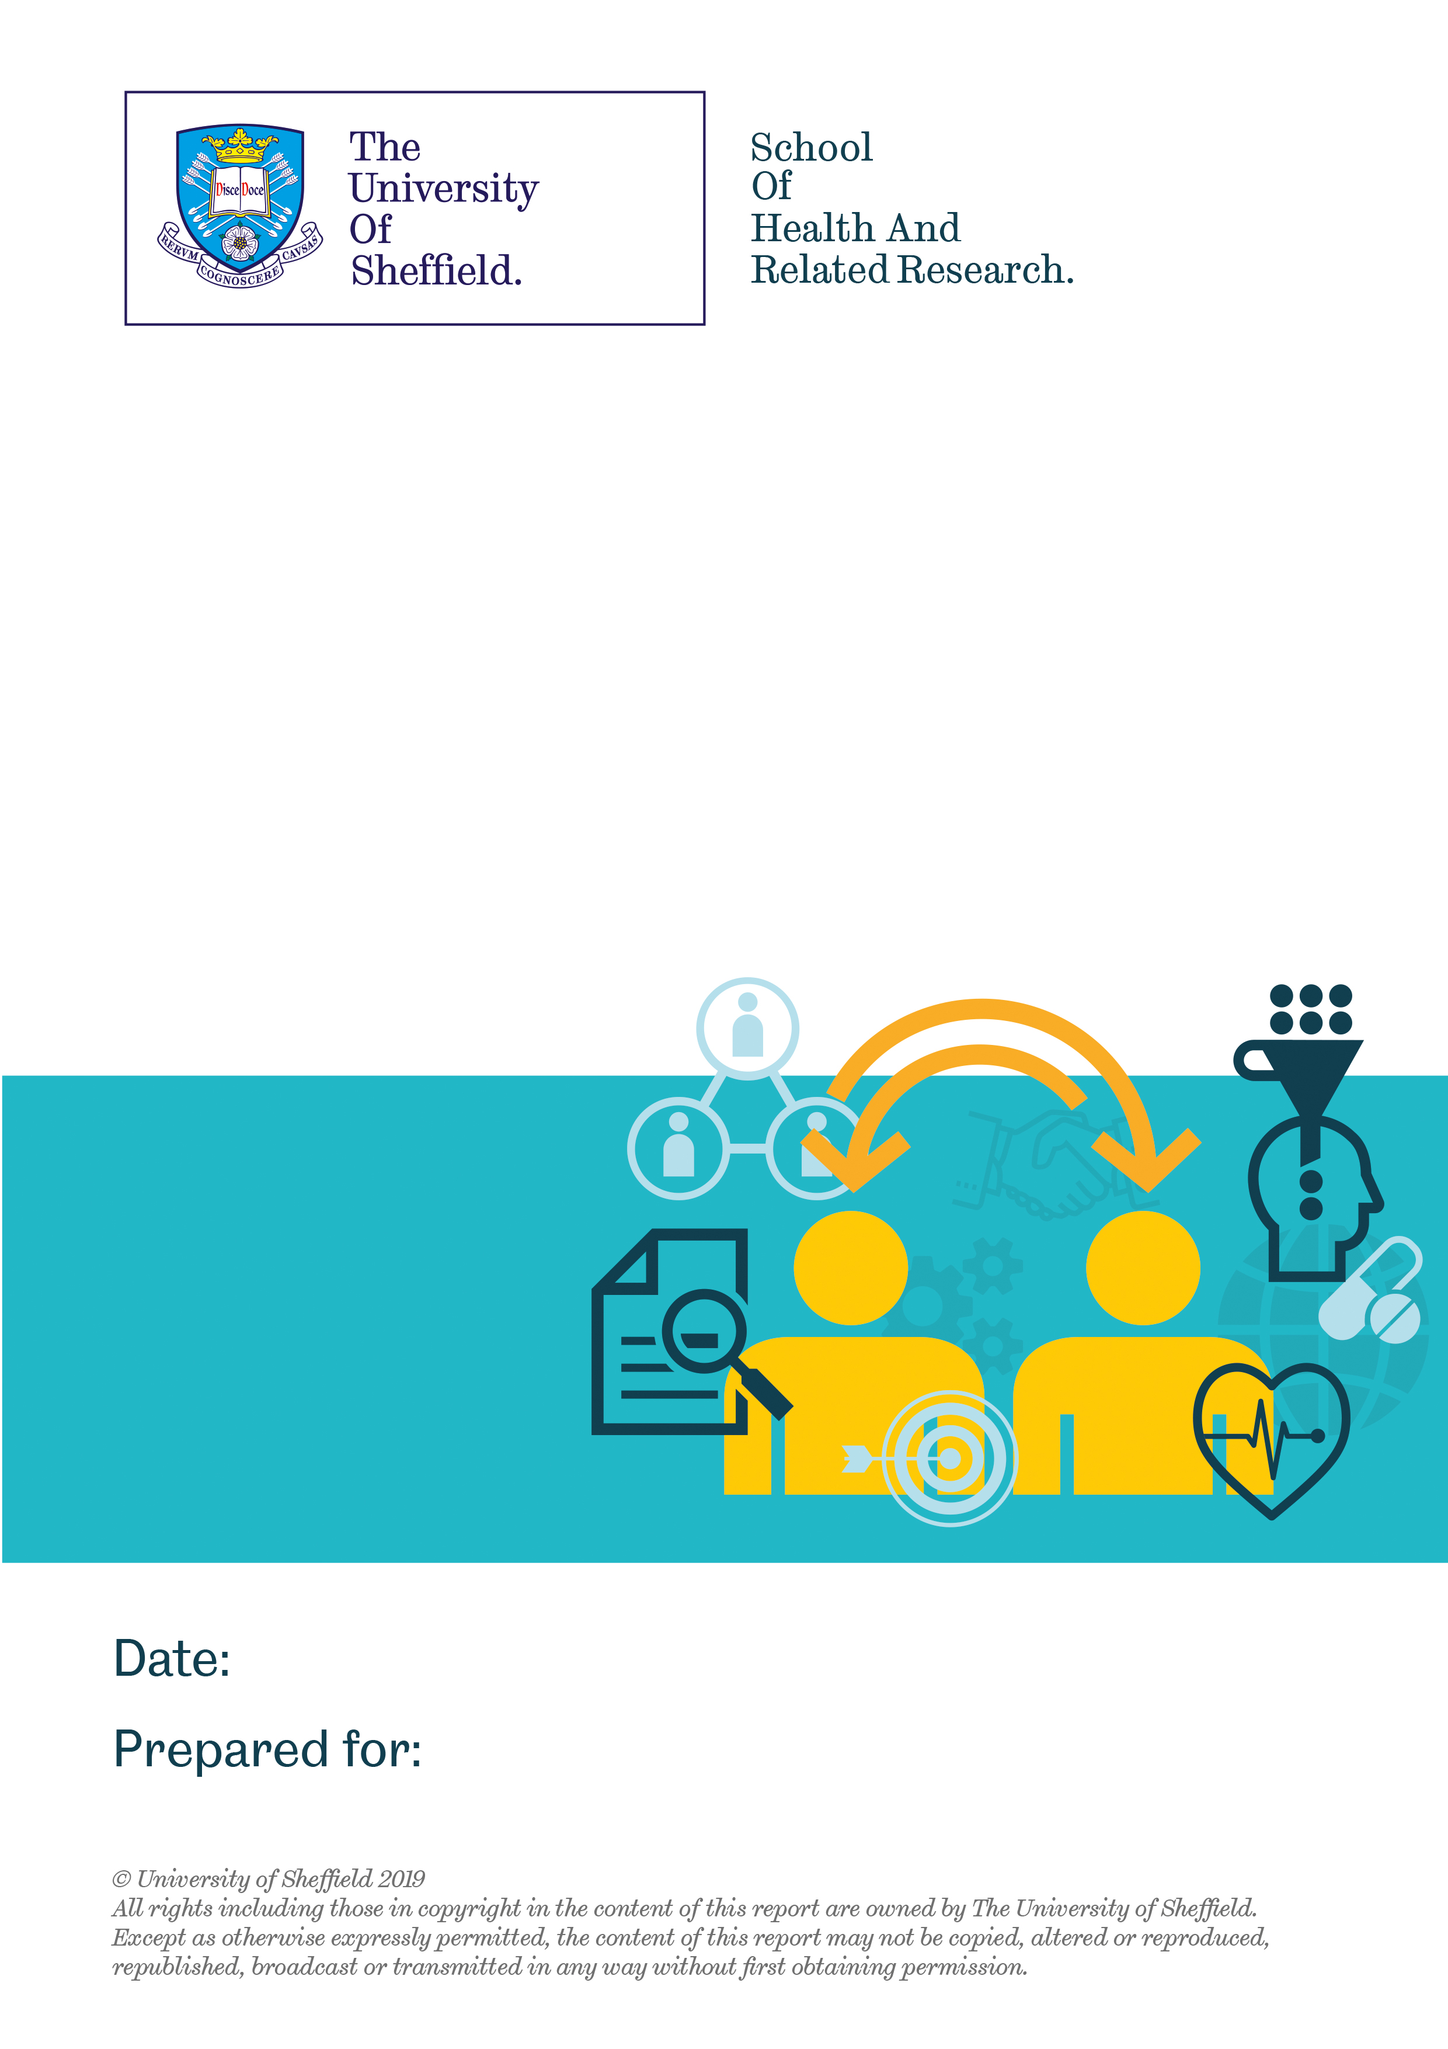

Evaluation of Cruse Bereavement Care’s ‘Bereavement Awareness Training’
Aimed at Military Personnel
Wednesday 17th June 2020
Cruse Bereavement Care

Contents
1. Introduction 3
2. Nature and location of the workshop 3
3. The wellbeing of people attending the workshop 4
4. Relevance of the workshop’s content 4
5. Increase in skills and confidence from attending the workshop 6
5.1 Whether people’s confidence in speaking with others has increased from attending the workshop 6
5.2 Whether people experienced an increase in knowledge on the challenges faced by people experiencing bereavement 6
5.3 Confidence in applying learning from the workshop when speaking with others 7
6. Skills of the trainers 7
7. The relevance of the training to peoples’ roles 7
8. Free-text comments 8
9. How the workshop appears to fit in with the theory of change for the programme 12
9.1 Implications of the evaluation 12
10. Summary 12
11. References 13

Table of tables
Table 1- Location of the workshops 3
Table 2- Relevancy of the workshop’s content 4

Table of figures
Figure 1- Number of attendees by specific military base 4
Figure 2- Relevancy of the workshop’s content 5
Figure 3- Confidence of attendees in the skills they acquired from the workshop and using these in practice 6
Figure 4- The relevancy of the workshop to attendees’ roles 8

Introduction

This document reports on the evaluation of bereavement awareness training for military personnel that Cruse has been delivering across the country. After completion of the workshop, attendees were asked to provide feedback using a standardised evaluation form, which was analysed by the University of Sheffield. The evaluation is based on the feedback of 190 attendees.

Data was collected via an evaluation form that people completed after attending the workshop. The evaluation form asked people questions about their wellbeing (the Office for National Statistics, 2018), their views about the workshop and any suggestions for improvement. The data collected was anonymised by Cruse before being transferred to the University of Sheffield in May 2020. Researchers at the University of Sheffield cleaned the data before analysing it using descriptive statistics (Field, 2009). The qualitative data collected through the free-text questions was grouped into categories and analysed thematically.

The report initially focuses on the content of the workshop, then consideration is given to whether people’s skills and confidence improved after receiving the training, followed by reflection on how the workshop could be improved.

Nature and location of the workshop

The workshop was a whole day session. It was delivered in a variety of military bases across the country, as detailed in Table 1 and Figure 1. The number of attendees from each military base who completed the evaluation questionnaire ranged from 6-26. There were 4 military bases from which just one person completed the evaluation questionnaire, these are classed as ‘other’.

Table 1- Location of the workshops
Location | Number (n=190) | Percentage
AWS Tidworth | 26 | 13.7
RAF Northholt | 24 | 12.6
RAF Conningsby | 20 | 10.5
RAF Cosford | 19 | 10
RAF Benson | 18 | 9.5
RAF Odiham | 16 | 8.4
RAF Marntham | 13 | 6.8
RAF Brize Norton | 12 | 6.3
RAF High Wycombe | 11 | 5.8
RAF Shrewsbury | 8 | 4.2
RAF Shawbury | 6 | 3.2
Other* | 4 | 2.2
Unknown* | 13 | 6.8

*Other and Unknown includes people from RAF, Navy and Army bases.

Figure 1- Number of attendees by specific military base

Summary: Attendees were from a variety of military bases.

The wellbeing of people attending the workshop

Less than 10 people answered the questions about their wellbeing. Therefore, it was not possible to analyse the data.

Relevance of the workshop’s content

The majority of respondents felt the workshop content was relevant, as described in Table 2 and Figure X.

Table 2- Relevancy of the workshop’s content
Relevancy | Models of bereavement  n= 190 (%) | What to say/not to say  n= 190 (%) | Self-care & resilience  n= 190 (%)
Very relevant | 96 (50.5) | 138 (72.6) | 121 (63.7)
Somewhat relevant | 58 (30.5) | 38 (20) | 53 (27.9)
Neither relevant nor irrelevant | 30 (15.8) | 11 (5.8) | 12 (6.3)
Somewhat irrelevant | 5 (2.6) | 3 (1.6) | 3 (1.6)
Very irrelevant | 1 (0.6) | 0 (0) | 1 (0.5)

Figure 2- Relevancy of the workshop’s content
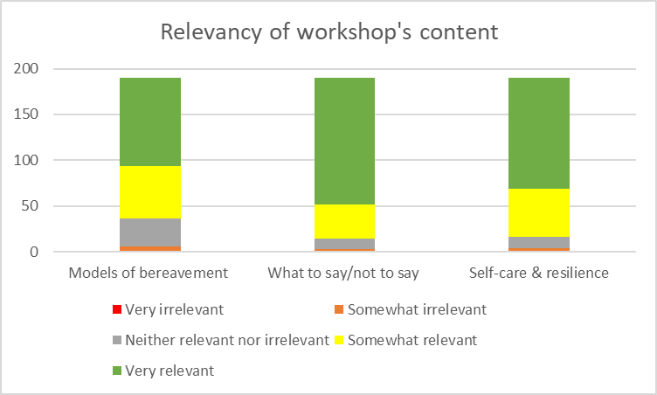

Learning about models of bereavement was considered relevant by over 80% of attendees (n=154). Less than 5% of attendees felt the content was irrelevant (n=6, 3.2%). There were some people who indicated that they did not consider the content either relevant or irrelevant (n=30, 15.8%). No specific feedback was given about why some attendees found this aspect of the workshop irrelevant.

Again, learning about what to say/not to say was considered relevant by the majority of attendees (n=168, 88.4%). Less than 10% of attendees did not find the content relevant (n=14, 7.4%). One attendee did comment how the workshop would be more relevant if there had been content on what to say to someone in the immediate aftermath of a death.

Finally, over 80% of people found the content on self-care and resilience relevant (n=174, 81.6%). Less than 10% did not find the content relevant (n=16, 8.4%).

Given the positive feedback, it is recommended that the content of the workshop is not changed in terms of continuing to include information about models of bereavement, what to say/not to say and information on self-care and resilience.

Summary: People found the content of the workshop relevant and thus it is recommended it is included in future training on bereavement.

Increase in skills and confidence from attending the workshop

Attendees generally felt that they had increased knowledge from attending the workshop and felt confident in applying this learning in their professional and personal lives (Figure X).

Figure 3- Confidence of attendees in the skills they acquired from the workshop and using these in practice

Whether people’s confidence in speaking with others has increased from attending the workshop

Most people felt attending the workshop increased their confidence to speak with others. (n=181, 95.3%). This indicates the workshop is helping people to increase their confidence.

Summary: The majority of people felt more confident speaking with others after attending the workshop.

Whether people experienced an increase in knowledge on the challenges faced by people experiencing bereavement

The majority of attendees reported having an increased knowledge of the challenges faced by people experiencing bereavement after attending the workshop (n=182, 95.6%) rated this question a 4 or 5, indicating the positive impact of the workshop. A small proportion of people did not feel the workshop increased their knowledge (n=8, 4.2%).

Summary: The majority of people found the workshop increased their knowledge about the challenges faced by people experiencing bereavement.

5.3 Confidence in applying learning from the workshop when speaking with others

The majority of attendees felt confident about applying their learning when speaking with others (n=177, (93.2%). A small number of people felt neither skilled nor unskilled with applying the learning (n=13 people, 6.8%). No one felt unconfident in applying their learning.

Summary: The majority of people felt confident using the learning from the workshop when speaking with others. This indicates the workshop is successful in helping to develop people’s skills.

Skills of the trainers

Attendees felt the trainers were very skilled and suitable to deliver the workshop (n=185, 97.4%). A small number of people felt the trainer was acceptable (n=5, 2.6%). No-one felt the trainers were unsuitable. Many of the additional comments provided by attendees were complementary of the trainer (discussed later). The positive feedback indicates Cruse are utilising the right people to deliver the workshop and ideally should continue to use the trainers.

Summary: The trainers were rated as highly skilled by attendees and it is recommended Cruse continue to utilise them.

The relevance of the training to peoples’ roles

People had mixed viewpoints about whether the learning from the workshop was relevant for their role (illustrated by Figure x). Over a third of people found the training relevant for their role (n=70, 36.8%). The same proportion of attendees felt the learning was neither relevant nor irrelevant for their role (n= 70, 36.8%). However a quarter of attendees did not find the learning relevant to their role (n=50, 26.4%). These people still rated the workshop highly and felt it was useful, just not to their specific role. This finding was interesting because the workshop had been targeted to certain personnel. It may be that these people felt they may not need to use the knowledge within their role.

Figure 4- The relevancy of the workshop to attendees’ roles
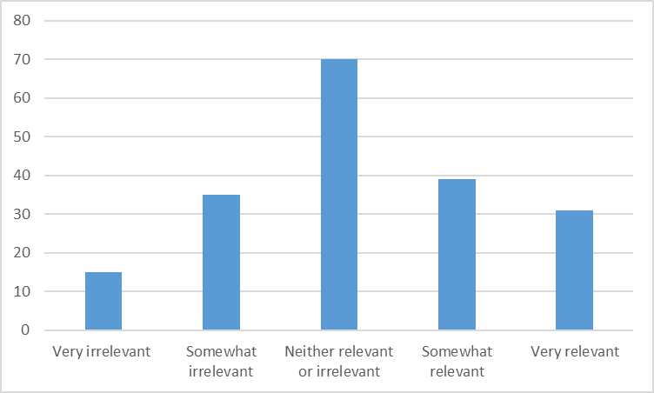

Summary: Generally, people felt the workshop was relevant to their role.

Free-text comments

Attendees were given the opportunity to provide comments on their perceptions of the workshop. This was specifically in relation to the content, skills-development and ideas about improving the workshop. In this section, the feedback from attendees is presented.

Comments about the usefulness and relevance of the workshop
Respondents felt the workshop was highly relevant, useful and transferable to both their work and personal lives. Some used it as a helpful ‘refresher’ and others thought it should be rolled out more widely. There were a vast number of comments relating to the fantastic trainers.

Highly relevant and useful
Overall, respondents were very positive about the training and the mixture of group and one to one learning. They felt it was highly relevant, enjoyable, interesting and worthwhile workshop, with appropriate, well delivered and clear content. People felt strongly they would be able to use the learning in the future.

“Good opportunity to discuss/share bereavement. Very friendly and relaxed manner”

“Proved to be a very worthwhile course which has added to my toolbox in my job role”

“The visual aids were great! They broke the models down into simpler ways of understanding. Well organised and everything ran smoothly

Transferable
A small number of attendees commented how the training was transferable and would be useful in both their everyday and work lives:

“Excellent. Works well for both work environment and private life”

A useful refresher
For some, the workshop was an excellent refresher, building on their existing knowledge and enhancing their skills:

“Having done some loss and bereavement courses in the past, this was a great refresher course”

Should be rolled out more extensively
Some responders felt the workshop should be available more widely within the military because would be beneficial:

“Absolutely spot on! Should be compulsory for personnel in welfare support roles”

“As an introduction into bereavement it was a great course which would benefit so many in my organisation”

Knowledgeable trainer
There were numerous positive comments about the excellent, experienced, confident, approachable and knowledgeable trainers. People appreciated the trainers’ expertise, presentation skills and how they were able to adapt the training to the needs of the group:

“It was clear that the trainer had a vast amount of experience in loss and bereavement. The real life examples he gave amplified the training appropriately”

“Very useful and relevant and was great how the trainer tried to make it specific to what we do”

“Very pleasant and well educated on the subject. Very informative and interesting”

A number mentioned their trainer by name and in glowing terms:

“Liz was very knowledgeable and pitched her instruction at the correct level”

“Very professional and relevant delivery from Adam”

“Christine was very knowledgeable and passionate - wow amazing Similar format to the loss and bereavement course run at AFCC”

“Exceptional delivery. David was excellent, professional”

How the workshop helped develop skills and knowledge of bereavement
Respondents enjoyed learning about the different models and felt the workshop had increased their confidence and understanding of loss and bereavement. They thought it was particularly useful to understand what to say and what not to say to a bereaved person and also have some affirmation that they were ‘doing the right thing’.

Understanding the models
Respondents enjoyed the theoretical aspect to the workshop and learning about the different models of bereavement and stages of grief:

“It has uncovered a lot of the different cause and effects surrounding bereavement”

“Interesting to talk through the different models”

Increased confidence and understanding of loss and bereavement
Some reported how the training had increased their confidence in their ability to deal with the process of bereavement and providing support to a bereaved person, for example having ‘difficult conversations’, listening skills or signposting to appropriate sources of support:

“[it has] given me the confidence to approach people in a calm, confident manner”

“Information gained will massively help with dealing with issues and sign posting in the future, and all round awareness in dealing with bereaved people”

“Allowed a better understanding of the emotional elements of grief and ways to help people help themselves through talking and active listening”

For many, the training increased their knowledge and provided a better understanding of all aspects of loss and bereavement, helping them to understand there are different types of grief and how this may affect people:

“Opened up my mind set about how to consider that all people deal with grief in a different way”

Learning what to say/what not to say
Respondents found it was hugely beneficial to learn the correct terminology to use, gain understanding on how to effectively communicate with people, particularly around what to say or what not to say to a person experiencing bereavement:

“It has been good to see how you should communicate with bereaved people. It’s not an automatically learned subject and I found this helpful, especially as I am unsure as to what to say”

Provided affirmation
For some, the workshop provided confirmation that they were doing the ‘right thing’ and a confidence in how much they already knew:

“Confirmed that the organisation and process that we have in place to support bereaved people is effective and appropriate”

How the workshop could be improved
The overall consensus was that people enjoyed the workshop with many feeling it should be increased in duration or extended to include more in depth training for specific groups. Respondents would have liked more practically based activities and suggested a number of additional topics that could be covered in future workshops.

Increase the duration
Respondents enjoyed the workshop so much that they felt it should be longer and perhaps spread across two days to allow more time for in depth coverage of topics and time for discussion. Some suggested bringing ‘experts’ into the workshop to emphasise the impact of grief, for example guest speakers who had suffered a bereavement:

“I feel that there was a lot to cover. There are so many situations and variables. What I did experience was extremely interesting and I would like to go into more depth, perhaps a longer course”

A small number felt the workshop was too generic and suggested following up with more in depth training such as masterclasses or online training to enable it to be tailored to the requirements of different groups of staff:

“I would be interested in masterclasses or more in depth training for my team”

“Maybe a bit more reflection on individuals’ experience of death specifically in a military context”

Practical exercises
A number of respondents thought the workshop should include more practical exercises to break up the taught elements. This could include role play, scenarios to test learning and digital media/video clips with examples of how to deal with/how not to deal with loss or bereavement:

“More scenario based exercises, for example role play and observation and discussion after to help consolidate understanding”

Additional topics
Additional topics were suggested for potential inclusion in the future. These included supporting the wider family, understanding child bereavement and miscarriage and how it impacted on families.

How the workshop appears to fit in with the theory of change for the programme

The feedback indicates delivery of the workshop is consistent with the programme’s theory of change. Attendees reported having a greater understanding of bereavement and feeling more confident to speak with people about bereavement, which reflects the short-term outcomes of the workshop. Whilst the evaluation could not identify whether the workshop improved the impact of unprocessed grief on people, there is suggestive evidence that attendees feel they could better support colleagues experiencing grief but also that they could better manage the grief they personally experience.

9.1 Implications of the evaluation

Positives
- The workshops appear to be exceptionally well-received by attendees.
- The content was considered relevant and useful so should remain as it is.
- The trainers were viewed as highly skilled and Cruse should continue to utilise them to deliver the workshops.
- The workshops helped people improve their knowledge, confidence and capability in supporting people experiencing bereavement.

Issues to reflect on
- A quarter of people did not feel the workshop was relevant to their role, this may be in issue with the evaluation question but is something Cruse may want to reflect on.
- The workshops could be made more interactive such as having more time for discussion.
- There is scope to make the workshop longer and include further information such as supporting someone after a miscarriage. Cruse may want to consider having an introductory workshop and follow-up workshop for people who want to learn more.

Summary

The workshop was well received by attendees. Generally, people felt the content was relevant and they improved their knowledge of bereavement and skills in supporting people. The trainers were considered exceptional and Cruse should continue to use them. Attendees found the workshop useful. The positive feedback given about the workshop indicates it is having a positive impact on people and it would be beneficial to continue delivering the workshop to military personnel.

References

Field, A. (2009). Discovering statistics using SPSS (3rd ed.). Thousand Oaks, CA: Sage.

Office for National Statistics. (2018). Personal Wellbeing in the UK (online). Available from: https://www.ons.gov.uk/peoplepopulationandcommunity/wellbeing/methodologies/personalwellbeingintheukqmi (accessed: 23/12/2019).

