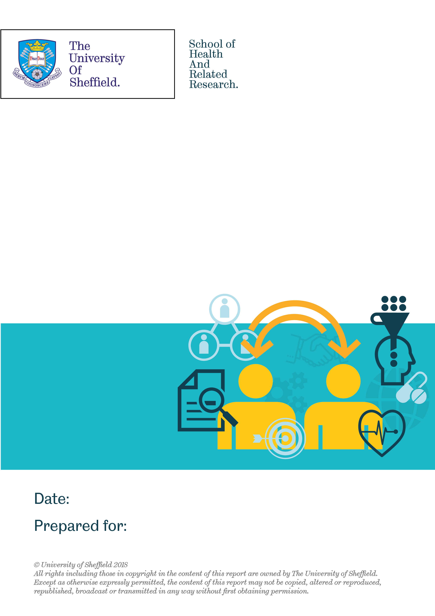

Cruse Bereavement Care
Tuesday 30th April 2019
Evaluation of Cruse Bereavement Care’s ‘More than Words’ Service

Contents
1. Introduction 3
2. Who accessed More than Words 3
3. How people accessed the programme 4
4. The support More than Words provided 4
5. Impact of the More than Words programme 6
5.1 Impact on Loneliness 6
5.2 Impact on wellbeing 7
5.3 Impact on vulnerabilities to grief 8
6. Other benefits 9
7. Qualitative analyses of free text survey questions 9
8. Sustainability 10
9. Summary 11
10. References 11

Introduction

This report is an analysis of the More than Words programme. The focus of this report is on the experience of clients who attended the programme and the impact of More than Words on people’s loneliness, general wellbeing and grief. This report also includes a brief qualitative analysis of four free text questions that participants were asked on completion of the service.

The report is based on the 57 participants who have completed both pre and post-questionnaires. The summary results of the survey are described in the following section. As not all respondents answered all of the questions, the sample size for each question differs. As the total number of respondents are small, this meant further statistical analysis involving subgroup analysis could not be performed.

Who accessed More than Words

The demographics of participants who completed the pre and post questionnaires are presented in Table 1. Based on the survey it is clear that More than Words reaches people from across the age spectrum. This also includes people from other age groups and not just the elderly, for example, a greater number of people aged 45-54 years accessed the programme than people aged over 65.

Of note, more than 80% of attendees were female, suggesting that men are less likely to participate in this programme. This gender difference is a common issue amongst these types of programmes and i reported elsewhere (Vandervoort, 2012). As can be seen in Table 1, there is a wide variation in the length of time participants have been bereaved, ranging from less than 3 months to over 10 years. The majority of respondents did not declare having a disability.

Table 1: The demographics of participants accessing the More than Words service

Demographic | Categories | Number | Percentage (%)
Age (years) | 18-24 | 4 | 7
 | 25-34 | 10 | 17.5
 | 35-44 | 7 | 12.3
 | 45-54 | 14 | 24.6
 | 55-64 | 10 | 17.5
 | 65+ | 12 | 21.1
 | Total | 57 | 100
Gender | Female | 47 | 82.5
 | Male | 10 | 13.5
 | Total | 57 | 100
Time since bereavement | 0-3 months | 11 | 19.3
 | 3-6 months | 9 | 15.8
 | 6-9 months | 2 | 3.5
 | 9-12 months | 6 | 10.5
 | 1-2 years | 6 | 10.5
 | 2-5 years | 11 | 19.3
 | 5-10 years | 5 | 8.8
 | Over 10 years | 3 | 5.3
 | Prefer not to say | 4 | 7.0
 | Total | 57 | 100
Disability | Yes | 7 | 12.3
 | No | 43 | 75.4
 | Prefer not to say/Other/Missing | 7 | 12.3
 | Total | 57 | 100

How people accessed the programme

More than Words is reaching new people as over 70% had not previously accessed Cruse services. Participants found out about More than Words in different ways, including via websites, social media and GP surgeries (see Figure 1 for breakdown – absolute numbers used). The most common method of finding out about the service was through the Cruse website, as well as through counsellors or GP surgeries. However, it was less common for clients to find out about the service via social media. This indicates that the Cruse website and promotion of the service through existing Cruse programmes and healthcare services have been to some extent effective in raising awareness about More than Words in the target client groups.

Figure 1: How participants found out about More than Words

The support More than Words provided

The sample of 56 participants completing the survey attended different More than Words groups. Twelve participants attended the Manchester group (21.4%), 10 attended the Birmingham group (17.8%) and two or fewer respondents were from the Leeds and Edinburgh groups (Figure 2). The sample is based on participants who completed the pre and post questionnaire and may not necessarily be representative of the different groups. In the questionnaire, three participants said they would prefer other locations for More than Words groups. However, these were spread across the country so cannot be used as a basis for selecting locations for further groups.

Figure 2: Number of participants accessing the More than Words groups by location (based on participants with a pre/post questionnaire)

In terms of the number of meetings participants attended, over a third attended five or more meetings (n= 20, 37.7%) (Figure 3). Less than 10% of respondents reported that they did not attend any meetings (n=5). The number of respondents attending between one and four meetings was fairly evenly spread.

Figure 3: Pie chart showing the number of meetings participants attended

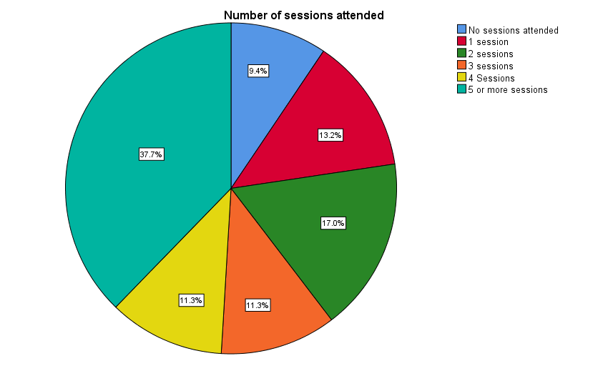
Footnote: Sample: n=53, No sessions attended: n= 5, 1 session attended: n=7, 2 sessions attended: n=3, 3 sessions attended: n= 6, 4 sessions attended: n=6, 5 or more sessions attended: n=20

One component of the More than Words programme is getting participants to become champions, with these champions subsequently then co-ordinating social activities for the groups. Of the sample of 57 participants, 21 became champions (10 of these initially registered as champions and a further 11 were recruited subsequently). In terms of proportion of respondents, this is just over a third of respondents becoming champions (36.8%). If this trend is reflective of other groups this would suggest that a considerable number of participants are willing to become champions. This is an important consideration that would enable this model to be feasible.

Impact of the More than Words programme

5.1 Impact on Loneliness
One of the purposes of More than Words is to help participants with their loneliness following bereavement. This was measured using the validated UCLA tool. Of the 54 participants who completed the pre and post service UCLA, 22.2% (n=12) became less lonely after accessing More than Words (Figure 4). The scores for 21 respondents (38.9%) were unchanged, i.e. indicating that they did not become lonelier over the period of the programme. This suggests that for more than 60% of participants the More than Words programme helped them to become less lonely or may have prevented them feeling lonelier. 38.9% (n=21) of the other respondents became lonelier between the pre and post questionnaire period. If analysis is focused only on those who attended at least one More than Words session (n=48), a slightly greater proportion of participants (n=12, 25%) experienced improvement in their loneliness scores.

The mean change was a slight deterioration of -0.37 points on the UCLA. The average UCLA score at the pre-questionnaire stage was 6.7 and at the post-questionnaire stage this had increased to seven (where the higher the score the lonelier someone is). However, this increase is slight and is an aggregate score, meaning it should be noted that some participants will have experienced an improvement in how lonely they felt whilst others may not.

Figure 4: Pie chart showing impact of More than Words on loneliness.

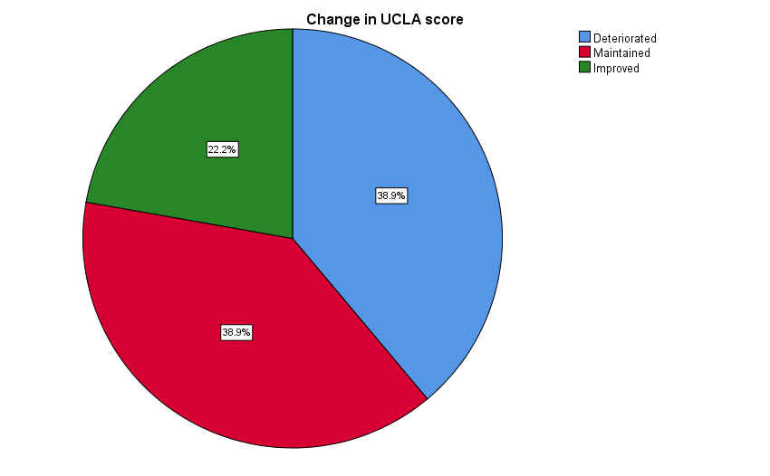
Sample: n=54, Improved: n=12, Maintained: n= 21, Deteriorated: n=21

On the UCLA score, there is a statistical cut-off, with anyone scoring six or more being classed as lonely. At the start of More than Words, 42 participants were classed as lonely (77.7%). The number increased slightly to 44 (81.5%) at the post-questionnaire stage. This indicates that some participants are becoming lonelier despite accessing the programme. However, this is not unsurprising and it would be reasonable to expect this to occur.

That said, generally the More than Words programme does help over half of participants to become less lonely or not to feel lonelier. This latter aspect is an important role for the programme. However, other participants do become lonely in that time. Some of this is explained by the qualitative feedback (discussed later in the report), such as participants wanting more sessions that they could access. Further exploration of the reasons for differences in loneliness outcomes will be explored in the final report in July 2019 when a larger sample will enable subgroup analysis.

5.2 Impact on wellbeing
Using the Short Warwick Edinburgh Mental Wellbeing Scale (SWEMWBS) the evaluation also explored whether More than Words helps to improve participants’ wellbeing (Figure 5). More than Words is supporting participants with lower levels of wellbeing. Amongst participants with a completed baseline wellbeing score, 85.7% had a level of wellbeing below the national average of 25 (n=48 of 56) (Office for National Statistics, 2018). Participants’ wellbeing did increase when accessing More than Words. Of the 54 participants with a pre and post service SWEMWBS score, 58% experienced an improvement in their wellbeing (n=29). A further 10% appeared to maintain their wellbeing scores (n=5). Just under a third experienced some deterioration in their wellbeing (n=16, 32%). The average wellbeing score before attending More than Words was 19.9 and the mean amount of change was +1.4 points (i.e. the average score at the post-questionnaire stage was 21.3).

Figure 5: Changes in wellbeing after accessing the More than Words programme

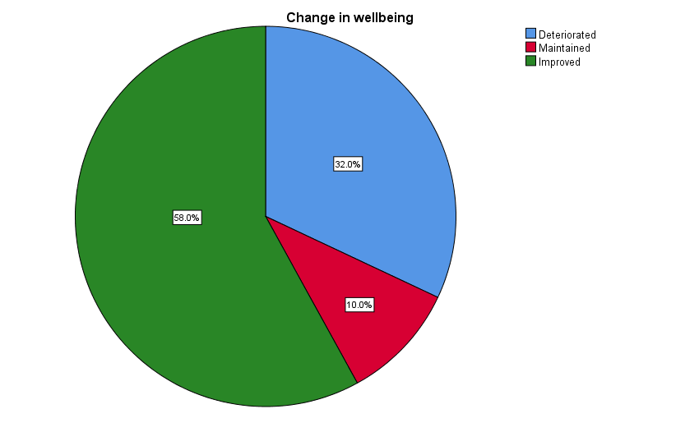
Footnote: Sample: n=50, Improved: n= 29, Maintained: n= 16, Deteriorated: n=5

Wellbeing was also assessed through a series of wellbeing questions based on the Office for National Statistics survey questions. These demonstrated that just under half of participants experienced some improvement after engaging with More than Words. 44.2% participants experienced an increase in life satisfaction (n=23 of 52 participants). Half of participants felt life was more worthwhile (n=26 of 52 participants). 42.3% of participants felt happier (n=22 of 52). Finally, 46.2% felt less anxious (n=24 of 52 participants). This demonstrates that More than Words is having a positive impact on some participants’ wellbeing and improving their anxiety levels.

5.3 Impact on vulnerabilities to grief
The impact of More than Words on participant’s grief was explored using the Adult Attitude to Grief (AAG) scale. The average grief score for respondents reduced from 21.8 to 21.2 points indicating a slight average reduction in the impact of grief. These scores indicate that as a sample, participants had high vulnerabilities associated with grief. On an individual basis, over half of participants experienced some improvement in their AAG score after accessing the More than Words programme (n=28, 58.3%) (Figure 6). This indicates that More than Words is helping many participants with their grief. There is also some evidence that participants’ AAG scores have improved with more being categorised as less severe. For example, at the start of the programme, 19 participants were categorised as having had a severe vulnerability associated with grief but this reduced to 17 at the post-questionnaire stage. Whilst numbers are small, it does indicate a positive shift.

Figure 6: Impact on vulnerabilities to grief

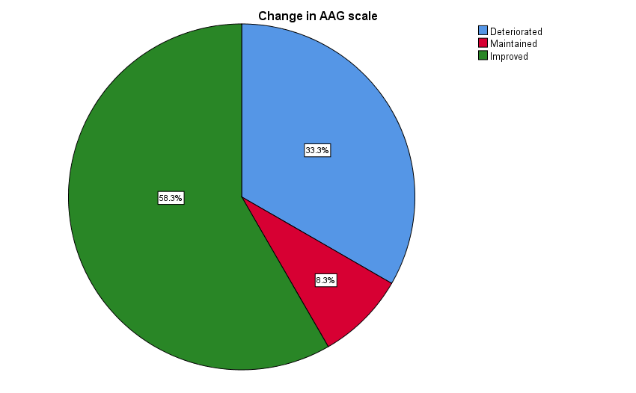
Footnote: Sample: n=48, Maintained: n= 4, Deteriorated: n=16, Improved: n=28

Other benefits

There was also a reported reduction in attendance at GPs for issues related to bereavement. Participants were asked whether they had visited their GP in relation to their bereavement in the last three months. Between starting in More than Words and completing the post service questionnaire, the proportion of participants who had sought their GP had reduced from 38.5% (n=20 of 52) to 26.9% (n=14 of 52). This is a considerable decrease, which would potentially generate cost savings for the NHS.

Just over half of respondents were more aware of other support they could access after engaging with More than Words (54.5%, n= 18 of 33). This suggests that there are corollary benefits as More than Words may help raise awareness of other support mechanisms available for people.

Qualitative analyses of free text survey questions

In addition to the quantitative survey, participants had the opportunity to respond to four free text questions relating to their experience of More than Words:

Has More than Words helped you in any particular way?
Participants felt that More than Words had helped them, had built their confidence and enabled them to talk to someone who understood their feelings. It offered support, as participants were able to meet others in a similar situation. Respondents felt the programme had helped them to see that it was possible to achieve more, enabled them understand the nature of their grief and connected them to social events that helped reduce feelings of social isolation and loneliness.

However, some felt that the service had not helped them. Reasons given for this included that some participants felt they could have benefitted from a longer period of support. One respondent stated that group bereavement support was lacking in their locality. Two respondents were disappointed with the service; one stated that they felt the purpose of the initial meeting seemed to be to recruit participants to run a group whilst another believed the meeting they attended was disorganised and unstructured. Communication appeared to be an issue as some reported receiving insufficient information about meetings or said they had not been given the opportunity to participate despite registering to attend More than Words. One person stated they were still waiting for details of meetings they could attend, whilst another had attended the initial training day but since then had received no follow up.

Is there anything you feel we could do to improve the service? What could we do to make the service better for you personally?
Participants felt there were not enough meetings and a lack of flexibility with regard to dates and times. Some felt that there should be more options relating to available venues and more flexible meeting times, for example, after 7pm Monday to Friday and weekends. Some felt that meetings were located too far away from where they lived, and that they should be held in easily accessible venues to accommodate those who have to rely on public transport. In addition, some felt More than Words should be better advertised, with clear updates about forthcoming events publicised on the website. Follow up events and meetings could be planned to enable participants to carry on meeting if they wished. Respondents felt that sessions should be better organised, with a real structure and a group leader whose purpose was to guide the conversations.

Do you have any general comments?
The general comments echoed responses made to the questions above, and although participants were generally positive that More than Words was good for people who were suffering loss and loneliness, the general comments focussed around requiring more frequent meetings at more convenient times and the lack of communication and information provided about meetings when someone had signed up.

Sustainability

- Whilst a small sample to date, More than Words appears to be having promising results especially in relation to preventing participants becoming lonelier, improving participants’ wellbeing and reducing their vulnerability to grief
- About a third of participants convert to becoming champions, indicating this model is feasible
- Participants want greater communication and co-ordination. This in turn suggests the need for greater paid staff capacity. Cruse may wish to reflect on whether this is undertaken centrally or whether there is a need for a more local approach. Responsibilities for different More than Words groups could be undertaken by a number of more locally based staff (e.g., in different regions)
- Cruse may also wish to reflect on the location of meetings, their frequency, when and where they take place as well as their structure in response to participants’ feedback
- Further reflection on the sustainability of the programme will be undertaken as part of the final evaluation report (July, 2019)

Summary

- More than Words is having a positive impact on participants, especially with regard to improving wellbeing, anxiety and their vulnerabilities associated with grief. Although only a few participants are experiencing an improvement in their loneliness, the programme is helping participants not to become lonelier
- Participants appear to be seeking their GPs less for issues relating to their bereavement which indicates that potentially More than Words is generating cost savings for the NHS
- About a third of attendees converted to champions indicating that this model appears to be working and is feasible
- Further analysis will be undertaken in July 2019. As this will be a larger dataset more subgroup analyses can be undertaken such as exploring differences in outcomes between the number of meetings participants attend

References

Office for National Statistics (2018) Surveys using our four personal well-being questions. Available at: https://www.ons.gov.uk/peoplepopulationandcommunity/wellbeing/methodologies/surveysusingthe4officefornationalstatisticspersonalwellbeingquestions. Last accessed 17/04/2019.
Vandervoort, D. (2012). Social Isolation and Gender. Current Psychology. 19 (3); 229-236.

