Modeling Musculoskeletal Dynamics During Gait:
Evaluating the Best Personalization Strategy Through Model Anatomical Consistency
Michele Conconi, Erica Montefiori, Nicola Sancisi and Claudia Mazzà
Table S1. Anthropometric parameters of the participants.
Participant ID | Age (years) | Mass (kg) | Height (m) | BMI (kg/m2) | Sex
Subject 1 | 10 | 41.0 | 1.37 | 21.84 | F
Subject 2 | 15 | 68.0 | 1.59 | 26.90 | F
Subject 3 | 9 | 49.0 | 1.41 | 24.65 | F
Subject 4 | 17 | 64.5 | 1.59 | 25.51 | F
Subject 5 | 10 | 25.0 | 1.29 | 15.02 | F
Subject 6 | 14 | 53.0 | 1.63 | 19.95 | F
Subject 7 | 8 | 23.0 | 1.25 | 14.72 | F
Subject 8 | 9 | 24.2 | 1.26 | 15.24 | F
Subject 9 | 10 | 37.0 | 1.42 | 18.35 | M
Subject 10 | 14 | 67.0 | 1.55 | 27.89 | F
average | 11.6 | 45.2 | 1.44 | 21.01
std | 3.1 | 17.9 | 0.15 | 5.09

Table S2. Peak values for significant output over the gait cycle on average cohort for the two family of MSK models and maximum absolute variation between them.
 | Joint model | M1  (no ankle joint internal forces) | M2  (considering ankle joint internal forces) | Max difference between M1 and M2
Ankle joint moment (N/Kg) | SGJ | 0.86 | 3.02 | 3.70
 | MFJ | 0.81 | 0.79 | 0.04
 | MCJ | 0.81 | 0.81 | 0.00
Hip JCF (BW) | SGJ | 3.94 | 3.94 | 0.46
 | MFJ | 3.95 | 3.95 | 0.02
 | MCJ | 3.96 | 3.96 | 0.00
Knee JCF (BW) | SGJ | 3.18 | 2.46 | 1.14
 | MFJ | 2.91 | 2.90 | 0.02
 | MCJ | 2.93 | 2.93 | 0.00
Ankle JCF (BW) | SGJ | 6.45 | 49.66 | 43.51
 | MFJ | 4.69 | 3.11 | 2.22
 | MCJ | 4.57 | 4.44 | 0.13
Soleus (BW) | SGJ | 3.82 | 0.28 | 3.65
 | MFJ | 2.39 | 2.28 | 0.16
 | MCJ | 2.24 | 2.24 | 0.00
Gas med (BW) | SGJ | 1.23 | 0.20 | 1.03
 | MFJ | 1.05 | 1.04 | 0.03
 | MCJ | 1.06 | 1.06 | 0.00

Table S3. Peak values for significant output over the gait cycle for individuals for the two family of MSK models and maximum absolute variation between them
 | Joint model | M1  (no ankle joint internal forces) | M2  (considering ankle joint internal forces) | Max difference between M1 and M2
Ankle joint moment (N/Kg) | SGJ | 1.04 | 12.42 | 13.30
 | MFJ | 1.00 | 0.93 | 0.15
 | MCJ | 1.03 | 1.03 | 0.00
Hip JCF(BW) | SGJ | 5.42 | 5.40 | 1.28
 | MFJ | 5.56 | 5.56 | 0.10
 | MCJ | 5.44 | 5.44 | 0.01
Knee JCF (BW) | SGJ | 5.52 | 3.65 | 2.48
 | MFJ | 5.43 | 5.42 | 0.10
 | MCJ | 5.60 | 5.60 | 0.01
Ankle JCF (BW) | SGJ | 10.55 | 126.80 | 120.83
 | MFJ | 6.43 | 8.24 | 6.85
 | MCJ | 6.00 | 5.92 | 0.76
Soleus (BW) | SGJ | 6.43 | 2.48 | 2.48
 | MFJ | 4.02 | 3.70 | 0.25
 | MCJ | 3.66 | 3.66 | 0.01
Gas med (BW) | SGJ | 2.09 | 1.28 | 0.47
 | MFJ | 1.98 | 1.98 | 0.09
 | MCJ | 2.11 | 2.11 | 0.01

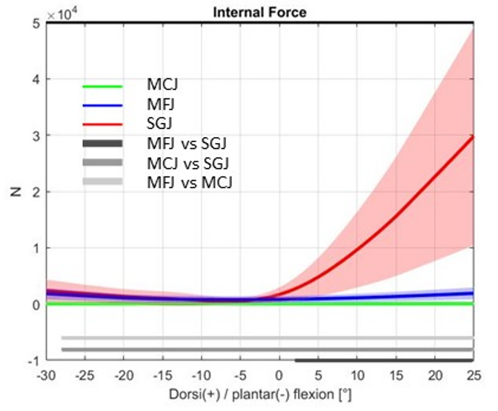 | 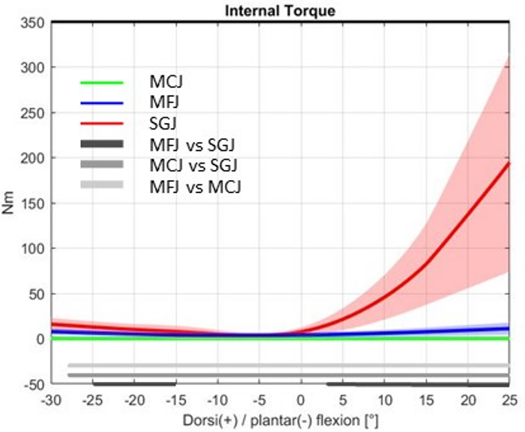
(A) | (B)
Figure S1. Resultant force (A) and resultant torque (B) of the ankle internal actions due to ligament and cartilage deformation for the average cohort, plotted versus ankle flexion angle for the three ankle models. Bottom gray bars represent the flexion angles where post-hoc tests were significant.
Figure S2. Motion componentes of the tibio-talar motion (abduction/adduction - AA; internal/external rotation - IEt; antero/posterior translation - X; prossimo/distal translation - Y; medio/lateral translation - Z) for the average cohort, plotted versus ankle flexion angle for the three ankle models. Bottom bars represent the flexion angles where post-hoc tests were significant.
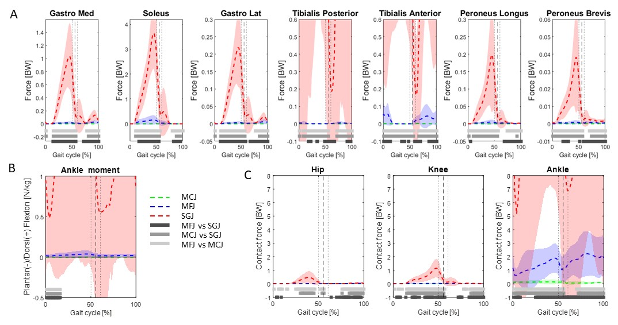
Figure S3. Differenced between M1 and M2 outputs for the average cohort: forces exerted for significant muscles at the ankle (A); joint moments (B); joint contact force (C). Bottom gray bars represent the region of the gait cycle where post-hoc tests were significant.

