Table A4: Results of the MatSciBERT software on the corpus.
As MatSciBERT gives a label to every word with the abstract, this means that the output for the data is not as simple as the other two data sets. Rather the raw data output is 100’s of lines long. Thus the raw data output for the first corpus is found here: here
The analysed data is given in the table below.
Paper |  | Result
[1] | 'Discovery of advanced soft-magnetic high entropy alloy (HEA) thin films are highly pursued to obtain unidentified functional materials. The figure of merit in current nanocrystalline HEA thin films relies in integration of a simple single-step electrochemical approach with a complex HEA system containing multiple elements with dissimilar crystal structures and large variation of melting points. A new family of Cobalt-Copper-Iron-Nickel-Zinc (Co-Cu-Fe-Ni-Zn) HEA thin films are prepared through pulse electrodeposition in aqueous medium, hosts nanocrystalline features in the range of ~5-20nm having FCC and BCC dual phases. The fabricated Co-Cu-Fe-Ni-Zn HEA thin films exhibited high saturation magnetization value of ~82emu/g, relatively low coercivity value of 19.5 Oe and remanent magnetization of 1.17%. Irrespective of the alloying of diamagnetic Zn and Cu with ferromagnetic Fe, Co, Ni elements, the HEA thin film has resulted in relatively high saturation magnetization which can provide useful insights for its potential unexplored applications.' | None
 | 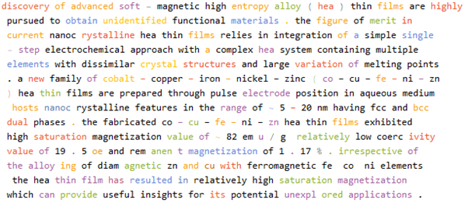
[2] | 'Multiprincipal-element alloys (MPEAs), including high-entropy alloys, are a new class of materials whose thermodynamical properties are mainly driven by configuration entropy, rather than enthalpy in the traditional alloys, especially at high temperatures. Herein, the design of a novel soft-magnetic nonequiatomic, quaternary MPEA is described, via tuning its chemical composition to deliberately manipulate its microstructure, such that it contains ultrafine ferromagnetic body-centered-cubic (BCC) coherent nanoprecipitates (3-7nm) uniformly distributed in a B2-phase matrix. The new alloy Al1.5 Co4 Fe2 Cr exhibits high saturation magnetization (MS = 135.3 emu g-1 ), low coercivity (HC = 127.3 A m-1 ), high Curie temperature (TC \xa0= 1061 K), and high electrical resistivity (ρ =44 μΩ cm), promising for soft magnets. More importantly, these prominent soft-magnetic properties are observed to be retained even after the alloy is thermally exposed at 873 K for 555 h, apparently attributable to the excellent stability of the coherent microstructure. The versatility of the magnetic properties of this new alloy is discussed in light of the microstructural change induced by tuning the chemical composition, and the enhanced performance of the alloy is compared directly with that of the traditional soft-magnetic alloys. The perspective is also addressed to design high-performance soft-magnetic alloys for high-temperature applications.' | None
 | 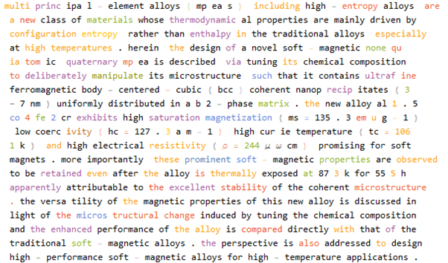
[3] | 'High silicon (Si) electrical steel has the potential for efficient use in applications such as electrical motors and generators with cost-effective in processing, but it is difficult to manufacture. Increasing the Si content beyond 3 wt.% improves magnetic and electrical properties, with 6.5 wt.% being achievable. The main goal of this research is to design, develop, and implement a scalable additive manufacturing process to fabricate Fe with 6.5 wt.% Si (Fe-6Si) steel with high magnetic permeability, high electrical resistivity, low coercivity, and low residual induction that other methods cannot achieve because of manufacturing limitations. Binder jet additive manufacturing was used to deposit near net shape components that were subsequently sintered via solid-state sintering to achieve near full densification. Here, it is shown that the use of solid-state sintering mitigates cracking since no rapid solidification occurs unlike fusion-based additive technologies. The Fe-6Si samples demonstrated an ultimate tensile strength of 434 MPa, electrical resistivity of 98 μΩ cm, and saturation magnetization of 1.83 T with low coercivity and high permeability. The results strongly supports to replace the only available 0.1 mm thick chemical vapor deposition (CVD) produced Si steel using the cost effective AM method with good mechanical and magnetic properties for motor applications.' | None
 | 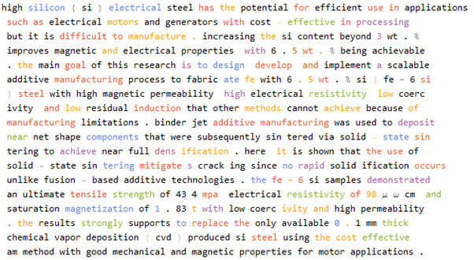
[4] | 'In this paper, a single phase ε-Fe(Si)₃N powder was successfully synthesized through the salt bath nitriding reaction method. The flaky FeSi alloy powder was used as the iron source, and non-toxic CO(NH₂)₂ was used as the nitrogen source. The nitridation mechanism, the preparation technology, the soft magnetic properties, and the magnetization temperature dependence of the powder were studied. The research result showed that ε-Fe(Si)₃N alloy powders were synthesized in a high temperature nitrification system after the surface of flaky FeSi alloy powders were activated by a high-energy ball mill. The optimum nitriding process was nitridation for 1 h at 550 °C. The ε-Fe(Si)₃N powder had good thermal stability at less than 478.8 °C. It was shown that ε-Fe(Si)₃N powder has good soft magnetic properties, and the saturation magnetization of the powder was up to 139 emu/g. The saturation magnetization of ε-Fe(Si)₃N powder remains basically constant in the temperature range of 300⁻400 K. In the temperature range of 400⁻600 K, the saturation magnetization decreases slightly with the increase of temperature, indicating that the magnetic ε-Fe(Si)₃N powder has good magnetization temperature dependence.' | None
 | 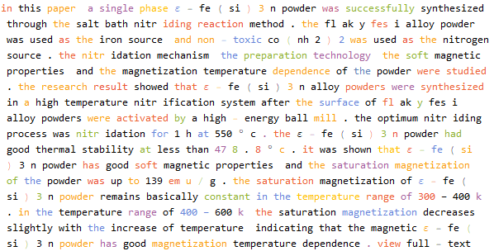
[5] | 'The soft magnetic properties of Fe-based nanocrystalline alloys are determined by their grain size. In the present article, the (Fe0.4Co0.6)79Nb₃B18 nanocrystalline alloys have been successfully prepared by isothermal annealing. The variation of soft magnetic properties as a function of annealing temperature and incubation time is investigated in detail. Two distinct crystallization behaviors were found for the (Fe0.4Co0.6)79Nb₃B18 alloys. The initial nanocrystallization products comprise a mixture of α-Fe(Co), Fe₂B, and Fe23B₆-type crystalline metastable phases, and the final crystallization products are composed of α-Fe(Co), Fe₂B, and Fe₃B crystalline phases. The grain size decreases first and then increases with the increasing annealing temperature in the range of 764⁻1151 K, and a fine grain size with mean grain size of 12.7 nm can be achieved for alloys annealed at 880 K. As the annealing temperature increases from 764 K to 1151 K, the saturation magnetization increases first and then decreases without a significant increase of the coercivity. The alloys annealed at 880 K exhibit the optimized soft magnetic properties with high Ms of 145 emu g-1 and low Hc of 0.04 Oe.' | None
 | 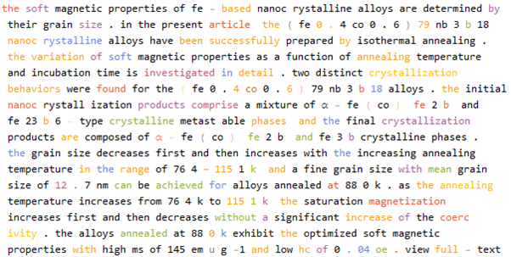
[6] | FeSiBAlNi (W5), FeSiBAlNiCo (W6-Co), and FeSiBAlNiGd (W6-Gd) high entropy alloys (HEAs) were prepared using a copper-mold casting method. Effects of Co and Gd additions combined with subsequent annealing on microstructures and magnetism were investigated. The as-cast W5 consists of BCC solid solution and FeSi-rich phase. The Gd addition induces the formation of body-centered cubic (BCC) and face-centered cubic (FCC) solid solutions for W6-Gd HEAs. Whereas, the as-cast W6-Co is composed of the FeSi-rich phase. During annealing, no new phases arise in the W6-Co HEA, indicating a good phase stability. The as-cast W5 has the highest hardness (1210 HV), which is mainly attributed to the strengthening effect of FeSi-rich phase evenly distributed in the solid solution matrix. The tested FeSiBAlNi-based HEAs possess soft magnetism. The saturated magnetization and remanence ratio of W6-Gd are distinctly enhanced from 10.93 emu/g to 62.78 emu/g and from 1.44% to 15.50% after the annealing treatment, respectively. The good magnetism of the as-annealed W6-Gd can be ascribed to the formation of Gd-oxides.' | None
 | 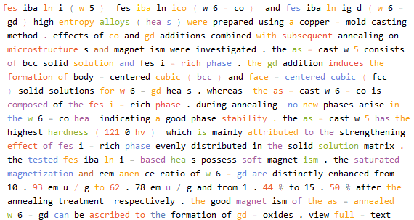
[7] | ‘'Strong static magnetic field (SSMF) is a unique way to regulate the microstructure and improve the properties of materials. FeCoNi(AlSi)0.2 alloy is a novel class of soft magnetic materials (SMMs) designed based on high-entropy alloy (HEA) concepts. In this study, a strong static magnetic field is introduced to tune the microstructure, mechanical, electrical and magnetic properties of FeCoNi(AlSi)0.2 high-entropy alloy. Results indicate that, with the increasing magnetic field intensity, the Vickers hardness and the saturation magnetization (Ms) increase firstly, and then decrease and reach the maximum at 5T, while the yield strength, the residual magnetization (Mr) and the coercivity (Hc) take the opposite trend. The resistivity values (ρ) are found to be enhanced by the increasing magnetic field intensity. The main reasons for the magnetic field on the above effects are interpreted by microstructure evolution (phase species and volume fraction), atomic-level structure and defects (vacancy and dislocation density).' | None
 | 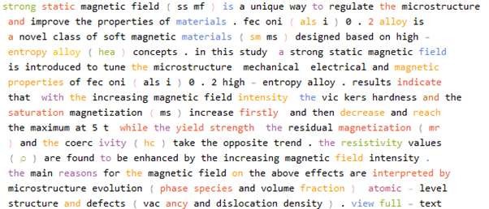
[8] | 'FeB@SiO2 amorphous particles were firstly introduced into Ga85.8In14.2 alloys to prepare metal-based magnetic fluids. The morphology of the FeB amorphous particles is spherical with an average particle size of about 190 nm. The shape of the particles is regular and the particle size is homogeneous. Stable core-shell structure SiO2 modified FeB amorphous particles are obtained and the thickness of the SiO2 coatings is observed to be about 40 nm. The results of VSM confirm that the saturation magnetization of the FeB amorphous particles is 131.5 emu g-1, which is almost two times higher than that of the Fe3O4 particles. The saturation magnetization of the FeB@SiO2 amorphous particles is 106.9 emu g-1, an approximate decrease of 18.7% due to the non-magnetic SiO2 coatings. The results from the torsional oscillation viscometer show that the metal-based magnetic fluids with FeB amorphous particles exhibit a desirable high temperature performance and are ideal candidates for high temperature use.' | None
 | 