Introducing Social Robots into the hospital environment: How do paediatric patients interact with social robots?

Research Protocol

Version | 2
Date | 08-Jun-2020
Study Period | 01/Jul/2020 – 01/Feb/2021

Investigators:

Brenda Littler
School of Health and Related Research
The University of Sheffield
bkmaleco1@sheffield.ac.uk

Professor Luc de Witte
School of Health and Related Research
The University of Sheffield
l.p.dewitte@sheffield.ac.uk

Dr Christine Smith
Deputy Head of Department
Sheffield Hallam University
chris.smith@shu.ac.uk

Professor Paul Dimitri
Professor of Child Health
Consultant in Paediatric Endocrinology
Sheffield Children’s NHS Foundation Trust
Paul.dimitri@nhs.net

LAY SUMMARY

Children who visit the hospital can experience a range of negative emotions, such as anxiety, distress and worry. Studies have shown that social robots have the potential of reducing negative emotions (Jibb et al., 2018). Social robots are autonomous robots that communicate and interact with humans through speech and movements (Huijnen et al., 2016). They are designed to act in a naturalistic way by using body language or vocalisation rather than a keypad (Collins et al., 2015). Social robots are currently being used to motivate children, teach social behaviours and support children with several physical disabilities.

This project aims to explore the interactions between paediatric patients and social robots. The study will aim to recruit 40 paediatric patients aged 5 to 12, who are visiting the Sheffield Children Hospital for a medical appointment. The study will be introducing three different types of social robots into five different hospital settings at the Sheffield Children’s hospital. The first robot that will be used is called Miro, an animal-like robot, the second one is NAO, a small humanoid robot, and the third one is Pepper, a tall humanoid robot. The humanoid robots will be programmed to talk and perform actions while interacting with each paediatric patient.

This study will be observing the types of interactions that occur between the child and the robot as well as the emotional impact the robot has on the child. The observation will be video record with the aim to understand what types of play occur between robots and the child when given the space to express themselves. Feedback and opinions from the parents/carers and health-related professionals will be collected, through questionnaires and interviews. The study will take place in five different settings within the hospital, allowing us to examine the feasibility of having social robots in the hospital. The study is being performed as a collaboration between Sheffield Children’s Hospital, University of Sheffield and Sheffield Hallam University.

General Information

Sponsor:  Sheffield Children’s NHS Foundation Trust  Western Bank  Sheffield  S10 2TH  United Kingdom | Sponsor’s Representative/Contact:  Dr Gillian Gatenby  Research Directorate Manager  Sheffield Children’s Hospital  gillian.gatenby@nhs.net
Chief Investigator:  Professor Luc de Witte  School of Health and Related Research  The University of Sheffield  l.p.dewitte@sheffield.ac.uk | Principal Investigator:  Professor Paul Dimitri  Professor of Child Health  Consultant in Paediatric Endocrinology  Sheffield Children Hospital  paul.dimitri@nhs.net
Co-Investigator:  Brenda Littler  School of Health and Related Research  The University of Sheffield  bkmaleco1@sheffield.ac.uk | Co-Investigator:  Dr Christine Smith  Deputy Head of Department  Sheffield Hallam University  chris.smith@shu.ac.uk

- BACKGROUND

For many paediatric patients, the hospital can be a stressful environment. It is known to be a busy, noisy, and sometimes unpleasant environment to be in. For a paediatric patient who is already experiencing pain, the additional activities of strangers prodding and asking questions can provoke an increased level of anxiety and stress. Studies have confirmed that children can be emotionally devastated when they are admitted into a hospital and can manifest their anxiety through crying, withdrawing and acting nervously (Li & Lopez, 2006; Li & Lam, 2003; Jeong et al., 2015). For this reason, many hospitals have been working hard to create welcoming spaces and provide play areas to develop a calmer environment for paediatric patients (Tranquada et al., 2013; Jeong et al., 2015). In some settings, music and video clips have been used as methods for distracting children from the pain and distress they may be experiencing.

In recent years, there has been a growing interest in the use of social robots within the health care sector. Researchers have provided evidence that social robots may be a suitable tool for reducing stress and anxiety in paediatric patients (Beran et al., 2013). Social robots are autonomous robots that interact with human beings through games, dance and conversation. This level of interaction from social roots creates a useful tool for encouraging social engagement among children of all ages and abilities. On the one hand, studies have investigated the impact of social robots on children in classroom environments, children suffering from several disabilities and children with Autistic Spectrum Disorder (ASD) (Huijnen, 2018; Heuvel, 2018; Jibb et al., 2018; Dawe et al.,2019).

On the other hand, there are a small number of studies that have explored the impact of social robots on paediatric patient’s anxiety levels. A study used an animal-like robot to assess how effective it would be in reducing anxiety and pain levels in children aged 6 to 16. The study found that levels of pain were slightly reduced, and there was a decrease in the experience of negative emotions (Okita, 2013). Limitations of the study included a female-only sample, parental involvement, and no mention of the specific types of interactions that occurred between the child and the robot. Many of the available studies lack a detailed explanation of the interaction process between the child and the robot (Alemi et al., 2016). Others have found that there is a potential for the use of social robots in a hospital environment. Still, more research is required to understand what occurs between a child in a hospital and a robot, as well as the role social robots, can play in hospital environments.

This study will be introducing three social robots into five different hospital environments at the Sheffield Children's Hospital. The research will be an exploration of how paediatric patients interact and play with social robots. The robots are MiRo, Pepper and NAO. MiRo is an animal-like robot which generates animal-like sounds and has sensory and motor abilities. Pepper and NAO are autonomous humanoid robots that interact verbally and physically with human beings. They can be programmed to move, talk and dance. The primary aim of this study is to explore the interaction between social robots and paediatric patients in a hospital environment, while the secondary objective is to assess the acceptability of social robots by health-related professionals and parents/carers.

Results from this study will provide a better understanding of the feasibility and the potential of having a social robot in a hospital environment. Alongside this, they will offer knowledge of the types of interactions children enjoy when it comes to engaging with a social robot. A follow-up study will take place aiming to explore the impact social robots have on reducing anxiety in paediatric patients aged 5 to 12. This current study is vital in providing the framework and information to design the follow-on study.
- STUDY OBJECTIVES AND PURPOSE

The overall aim of the study is to explore the interaction and acceptability of social robots by paediatric patients, health-related professionals and parents/carers, in a series of hospital settings.

Objectives:
- To establish which types of interactions occur when paediatric patients are interacting with social robots by observing patterns of behaviours.
- To evaluate the acceptability of social robots in a hospital environment by interviewing members of staff.
- To gather parents/carers’ opinions on social robots in hospital environments via questionnaires.

In direct answer to the research question, this study will use observation, questionnaires and interviews to gather information on the use of social robots in hospital environments. These methods have been found in previous research to be the most appropriate when studying interaction between social robots and humans (Kim et al., 2013; Beran et al., 2013).

- STUDY DESIGN

This study will be using qualitative methods to gain an understanding of how children interact with social robots when they are in the hospital. The study will be using three qualitative assessments, observation via video and audio recording, questionnaires and interviews.

  - Methods

    - Observation

40 participants will be recruited to take part in the study. They will be observed via video recorded while interacting with a social robot in order to discover the types of play and patterns that occur between a child in the hospital and a robot. Each observation will last up to 20 minutes depending on the age. Observation allows for rich data to be collected in real-life situations. Using video recording to capture the data will allow for expressed first-hand emotions and behaviours to be captured and analysed. Observation also allows the researcher to understand the user’s needs, likes and dislikes. The goal of the researcher during observations is to cause as little disruption as possible, taking an insider perspective in which they talk to participants as well as observe but do not disrupt (Preece, 2002).

3.1.2 Questionnaires

A questionnaire will be given to each participant at the end of the interaction. As well as the parent/carer of the participant. The parent/career will be asked to fill in a question before and after their child’s interaction. Questionnaires allow for well-established feedback to be collected. The study will involve three types of questionnaires. One will be given to the participants with the aim of gathering information on their experience with the robot. Two questionnaires will be given to the parent/carer. The first one of the two questionnaires will be to gather information on the child and their emotional state. The second questionnaire will gather their views on the impact the robot may have had on their child as well as their opinion regarding social robots in hospital environments.

3.1.3 Interviews

Ten health-related professionals will be recruited and interviewed for their opinions on social robots in hospital environments. Health-related professionals will be asked to take part in semi-structured interviews. Each interview will be no longer than 45 minutes. The aim of the interviews will be to discover the use and acceptability of social robots in the five different hospital environments from the perspective of health-related professional working in those environments. Semi-structured interviews allow for questions to be prepared ahead of time while also allowing information to flow and give interviewees the freedom to express their views on their own terms.

A diagram of the research methods and aims:

- SELECTION OF PARTICIPANTS

The study will involve three groups of participants – health-related professionals, paediatric patients and their parent/carer.

  - Inclusion and Exclusion Criteria

    - Health related professionals’ participants

Inclusion criteria:
- Health-related professionals who work at Sheffield Children Hospital.
- Ward manager of the selected settings
- Staff nurse in the selected setting

Exclusion criteria:
- Health-related professionals who are not employed by Sheffield Children’s Hospital

    - Paediatric participants

Inclusion criteria:
- Paediatric participants between the ages of 5 and 12 years
- Any gender, background and socio-demographic characteristics.
- Able to speak fluent English
- Visiting the hospital for a medical appointment

Exclusion criteria:
- Paediatric participants outside of the age range
- Children who are not waiting to be seen by hospital staff, e.g. siblings of patients
- Patients with visual, auditory, or cognitive impairments and end-of-life patients
- Patients experiencing extreme pain or being medically unstable
- Paediatric patients whose parents are unable to speak English

    - Parent/carer participants

Inclusion criteria:
- Parent/carer of participant and able to read and speak fluent English

Exclusion criteria:
- Not a parent/carer of the paediatric patient involved in the study

- PARTICIPANTS RECRUITMENT

  - Identification and recruitment of participants

5.1.1 Identification and recruitment of health-related professional participants

The aim is to recruit ten health-related professionals to interview. The study will be conducted in five hospital settings and will aim to recruit a ward manager and a staff nurse in each of the five settings. They will be given an information sheet, that will explain the study and give all the relevant information. After some time of consideration, up to 24 hours, a consent form will be given to them to sign if they choose to take part.

5.1.2 Identification and recruitment of paediatric participants

The aim is to recruit 40 participants. There are no reliable statistics on the number of participants we would need to recruit. The target sample size has been chosen based on the timeframe of the study and upon prior studies. The sampling technique will be purposeful sampling. Hospital staff will identify potential participants on the days of the study. To balance the ages, we will aim to select 20 participants from the ages 5 to 8 and another 20 from the ages 9 to 12.

The hospital staff will make the first approach to inform the potential participants about the study and ask if they would like to find out more. The potential participant will be given an age appropriate information sheet, which they can go through with a parent/carer. Parents and carers will also be given an information sheet about the study. They will be given up to 60 minutes to decide about their participation in the study but can choose to participate in the 60-minute timeframe. The information sheets will include the goals of the study and exactly what they should expect if they participate. They will be informed that personal details will be kept confidential, and will only be used for the purpose of this study. They will be informed that the robot interaction will be video, and audio recorded for research purposes only, and that a questionnaire will be given to them after the interaction. There will be two types of information sheets: (1) for participant aged 5 to 8 and (2) for participant aged 9 to 12.

Individuals who are happy to participate will have their parents sign a consent form on their behalf. The form will ask several questions ensuring the participant has understood the aims of the study, what is involved in the study, and that they can stop taking part in the study at any time.

5.1.3 Identification and recruitment of parent/carer participants

Parent/carer of participants will also be given an information sheet regarding the purpose of the study, and about their child’s involvement. Information about the risks and benefits and what we will require from them as part of the study will be explained. The study will need the parent/carer to take part in the study as well. They will be asked to complete two questionnaires, one at the start, regarding information about the child’s age, health and emotions towards the hospital visit. Once the robot interaction is over, another questionnaire will be given to explore their views on social robots being a tool within a hospital environment. A consent form will also be given to the parent to fill in.

5.2 Benefit to Participant

There is no direct benefit for the participants that take part in the study. The information gathered will hopefully help children and young people who visit the hospital in the future.

5.3 Withdrawal of Participant

Participants can withdraw at any stage of the study. If a participant starts becoming distressed, the parent/carer of the participant will be called over (if away from the study setting). The parent/carer will have the option to withdraw their child from the study if they wish. If a participant chose to withdraw from the study the data already collected will be kept, but there will be no further collection of data. The data may be used in this study but will not be used in future research. It will also benefit the team to collect reasons to why a participant has chosen to leave and therefore, the researcher will ask the participant for a reason for their decision.

6.0 Data Collection

6.1 Observation (via video recording)

The video and audio recording will be done with two cameras in a fixed place, explicitly focusing on the interaction between the participant and the robot. The video camera will aim to capture movement, speech and the types of plays that occur from different angles. Using video recording to capture the interaction will limit the risk of missing key details, allowing for the focus to be on one individual at a time and for rich data to be collected (Asan and Montague, 2014). The participant will be interacting with the robot on their own rather than in a group. Studying one child at a time will increase the likelihood of capturing each child’s movement and interaction with the social robot in great detail (Price et al., n.d). Fieldnotes will also be taken when necessary during the observations.

6.2 Questionnaire

There will be three questionnaires used in this study. The first questionnaire will be given to the parent/carer of the participant before the interaction. The questionnaire will seek to gather information about the child and their emotions. The second questionnaire will be given to the participant once they have finished interacting with the social robot. It will seek to gather information on the use of social robots in a hospital environment, from their perspective. The third questionnaire will be given to the parent/carer once the interaction is over. The questionnaire will seek to gather parent/carer's opinions on social robots as a tool in the hospital environment. All the questionnaires will be in paper form and will be distributed by the researcher. Each participant will need to fill in the questionnaire on the day at the scene of the study.

6.3 Interviews

A ward manager and a staff nurse will be chosen from each environment to take part in a semi-structured interview. The interviews will happen after all interactions, between the children and the social robots, have taken place in that particular environment. A topic guide will be used during the interview to support the researcher. An encrypted audio dictaphone will be used, as a tool, to capture the conversation and then transcribed.

7.0 STUDY SETTING

The five-hospital settings are (A) Haematology Oncology Day Unit, (B) Medical Day Care, (C) Theatre Admission Unit, (D) Outpatients Environment and (E) The Ward Environment. After a few visits to the hospital and conversations with several hospital staffs, these five settings were chosen as being the most suitable and feasible environments to capture interactions between a social robot and a child.

Each setting has enough space to separate the interaction with the child and robot, from the general hospital users. At each of the settings, a social robot will be introduced to interact with a participant for up to 20 minutes. The interactions will be semi-structured, involving planned activities and space for the child to direct the types of interactions that occur.

The table below shows the best time to visit each setting

Setting (image) | Best time to visit
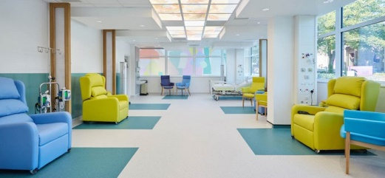  Haematology Oncology Day Care Unit | Not Tuesday or Thursday  Wednesday or Monday are better, between 11am to 1pm.
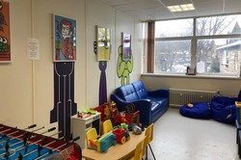  Medical Day Care | Between 10am to 2pm any day of the week (Mon – Fri)
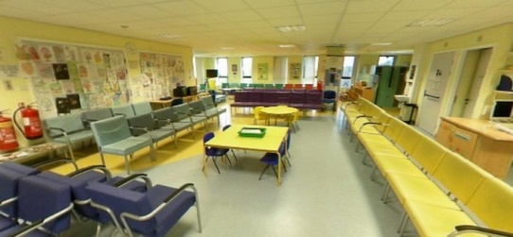  Theatre Admission Unit | Between 9am to 11am or after 2pm any day of the week (Mon-Fri)
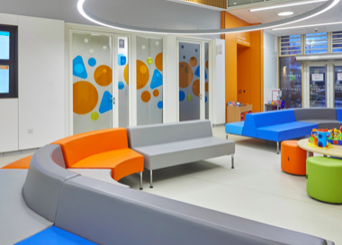  Outpatients Environment | Opens from 7am to 8pm and can be visited at any part of the weekdays
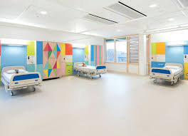  The Ward Environment | Anyday between 9am to 3pm

7.1 Haematology Oncology Day Care Unit
This department is for children with cancer and leukaemia. Paediatric patients with bleeding disorders and inherited disorder of red cells disorder are also treated at this department.

7.2 Medical Day Care
Medical Day Care is a centre for paediatric patients to attend to have a blood test, assessments, medical reviews, cannulation, lumbar punctures and infusions. The study will take place in the waiting area. Paediatric patients who attend the day care sometimes require a quick procedure or an all-day infusion.

7.3 Theatre Admission Unit
The Theatre Admission Unit (TAU) is where paediatric patients are prepared for surgery or a procedure that requires a general anaesthetic. Nearly all the paediatric patients who go to the theatre come to the TAU before their operation.

7.4 Outpatients Environment
The outpatient’s department treats paediatric patients with a variety of different conditions. The outpatient's Hub is a large waiting room area which opens from 7 am to 8 pm.

7.5 The Ward Environment
The wards are where paediatric patients stay for over 24 hours, with a variety of medical conditions.

7.6 Study schedule

The hospital is an unpredictable location, and things change and move quickly. At the moment, the plan is to visit each setting on an allocated day of the week. For example, every Wednesday for the next nine weeks, the study will be scheduled to take place in the Haematology Oncology Day Care unit. This way, the staff members of each setting will be aware of and expecting the research to take place. The days of the visit will be decided after NHS approval and closer to the time.

The nine weeks is a provisional schedule. In each setting, the aim is to recruit eight participants. Once eight participants have been recruited, the study will no longer take place there. For example, if by week 3 eight participants were involved in the study from Setting A, the research team will no longer visit that particular setting.

Week | Monday | Tuesday | Wednesday | Thursday | Friday
Week 1 -  Robot 1 | Setting A | Setting B | Setting C | Setting D | Setting E
Week 2 –  Robot 2 | Setting A | Setting B | Setting C | Setting D | Setting E
Week 3 –  Robot 3 | Setting A | Setting B | Setting C | Setting D | Setting E
Week 4 –  Robot 1 | Setting A | Setting B | Setting C | Setting D | Setting E
Week 5 –  Robot 2 | Setting A | Setting B | Setting C | Setting D | Setting E
Week 6 –  Robot 3 | Setting A | Setting B | Setting C | Setting D | Setting E
Week 7 –  Robot 1 | Setting A | Setting B | Setting C | Setting D | Setting E
Week 8 –  Robot 2 | Setting A | Setting B | Setting C | Setting D | Setting E
Week 9 –  Robot 3 | Setting A | Setting B | Setting C | Setting D | Setting E

8.0 INTERVENTION

Once the participant is recruited, they will be introduced to the setting and shown around. The researcher will explain the aims of the study and answer any questions the child or parents/carers may have. Parents/carers will then be given a questionnaire to fill in regarding the participant’s age and gender, their reason for the hospital visit and their child’s current mood. After that, the participants will be introduced to one of the social robots MiRo, Pepper or Nao.

Social Robots
Name | Description | Features
MiRo  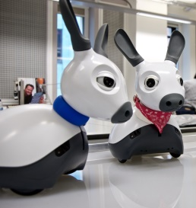 | MiRo is an animal like robot which generates animal-like sounds and has a sufficient sensory and motor ability. | Sensors including stereo vision and hearing, ultrasonic ranging, light level sensors, infrared cliff sensors, tactile sensors on the body and head, and interceptive sensors such as twin accelerometers, joint position sensors
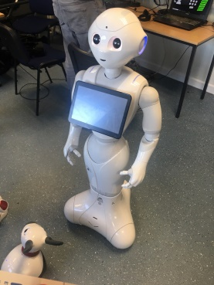  Pepper | Pepper is a humanoid robot who is able to recognise faces and basic human emotions. Pepper was optimised for human interaction and is able to engage with people through conversation and his touch screen | 1210mm tall  Atom E3845 processor  Ethernet  Microphones on the head (x4)
NAO  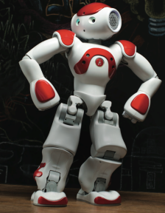 | Humanoid robot for education, healthcare, and research. Made up of a unique combination of hardware and software, NAO consists of sensors, motors and software driven by NAOqi, a dedicated operating system. | 50cm tall  25 degree of freedom  Has cameras, microphones, speakers, touch sensors and LEDs  Capable of speech and touch

Ideally, we want the participant to interact with the social robot on their own, but if a participant needs support and seems distressed, a parent/carer will be advised to stay with them. If the participant settles down, the parent/carer will be encouraged to move away from the interaction between the child and the social robot. The interaction between the social robot and the participant will be captured via video and audio recording. The interaction will be semi-structured, meaning that part of the interaction will be led by the researcher, and part of the play will be directed by the child. There are four scenarios that will be exploring different types of play.

Scenarios | MiRo | Pepper | NAO
Scenario A  Storytelling  3 minutes | Miro is animal-like robot and therefore cannot speak. The storytelling scenario will involve role playing and having Miro the main character of the story. | Pepper will have two books that will be programmed in its system. One will be for 5 to 8-year olds and another will be for 9 to 12-year olds. | Nao will have two books that will be programmed in its system. One will be for 5 to 8-year olds and another will be for 9 to 12-year olds.
Scenario B  Movement  4 minutes | Miro has the ability to move around on its own. So, the child will be asked to encourage Miro to move closer to them and away. | Pepper will perform a dance. It has three dance mode: disco, Tai Chi and head movement dance. It can also pretend to play music instruments such as the saxophone and guitar. | Nao will perform a dance. It has three dance mode: disco, Tai Chi and head movement dance. It can also pretend to play music instruments such as the saxophone and guitar.
Scenario C  Game  3 minutes | Miro is very good at detecting movement and so a game will be designed called follow me. This will involve the kids going through an obstacle and having the robot follow them. | Pepper will play a series of mini games with the child, such as Pepper Says | NAO will play a series of mini games with the child, such as NAO Says
Scenario D  Choice of activity  5 to 10 minutes | The child will be able to play with Miro as they would choose. | There will be a selection of stories, dances and quizzes the child can choose to interact with. | There will be a selection of stories, dances and quizzes the child can choose to interact with.

The researcher’s role will be encouraging play between the social robot. There will be hospital staff close by in case of any medical requirements. Each participant will be given up to 20 minutes to interact with the robot. The researcher will operate two of the social robot, Nao and Pepper, from a laptop. The interaction is all pre-programmed and therefore, will only require the researcher to press play, and once the interaction has started, it gives them time to return to the child. Before each session, the surface of the robots will be cleaned using a soft damp cloth, and then dried with a soft dry cloth to remove humidity.

After the interaction with the robot, a questionnaire will be given to the participant. The questionnaire will seek to gather information about the interaction and their experience. Parents/carers can support their child in answering the questions and therefore would be called back into the room/space if they are away from it. They will also be given a questionnaire regarding their feedback on the use of social robots in hospital environments to answer.

Rough script regarding the scenarios
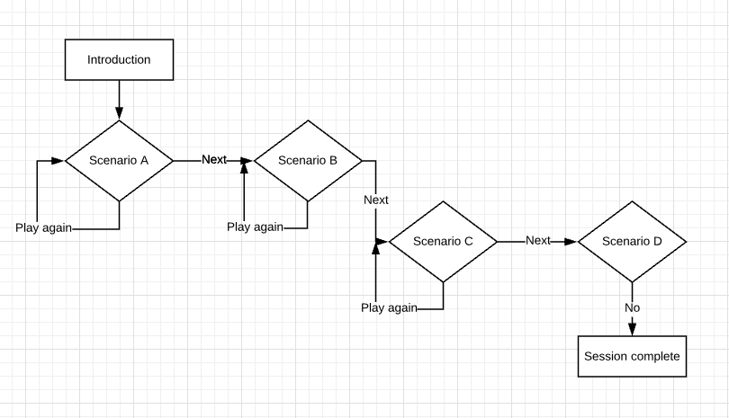

We are aware that children might want to stay a bit longer to play with the robot. If this does not get in the way of their medical appointment, we will turn off the camera after 20 minutes and allow the child to have a further 10 minutes play with the robot.
- DATA MANAGEMENT AND RECORDING KEEPING

All investigators and study site staff must comply with the requirements of the Data Protection Act 2018 with regards to the collection, storage, processing and disclosure of personal information and will uphold the Act’s core principles.

9.1 Roles and responsibilities

The chief investigator (CI), principal investigator (PI) and student have the responsibility of collecting and storing away the video and audio recordings, the questionnaire and any field notes. They will be responsible for saving all media and text files in the field on the University of Sheffield file store (x: drive) and then depositing all files in an archive. All the paper documents will be kept in a locked cabinet at the Sheffield Children NHS Foundation Trust, Research and Innovation department only the research team will have access to.

9.2 Types of data and scale

Qualitative data will be collected from observations, questionnaires and interviews. The interaction between the participant and the social robots will be video and audio recording using cameras. Participants and their parent/carer will be given a paper questionnaire at the start and the end to completed, to gather data of the reaction toward social robots in hospital environments. Interviews will occur with health-related professional to investigate their opinion regarding the use and role of social robots inside hospital environments. The scale of data that will be gathered will be: (i) approximately 14 hours of video and audio, (ii) 120 questionnaires from participants and parents/carers, (iii) accompanying text files that will contain transcriptions and any other relevant annotations related to the media files and (iv) 450 minutes of audio-recorded interviews with health-related professionals.

9.3 Format of the data

All the video recorded gathered will be saved in a MPEG-2 format, and any test files that accompany the media data will be kept in a Microsoft Word document. The paper questionnaire will be transcribed, and catalogue into a Microsoft Excel spreadsheet document and the audio data will be in a WAV format. These formats are reliable and readable over a long period. Data will be stored in three different locations the university networked file store (X: drive), google drive and the university local drive. The university networked file store (x: drive) it provides shared storage which is secure and accessible on and off campus. It is also backed up several times each day and gives the option to restore earlier versions. Google drive service meets data security and privacy requirements and enables access-controlled collaboration with project partners within and outside the University. Google Drive will not be used for sensitive data. The university local drive will be used on a short-term basis but will not be relied upon for storing master copies.

9.4 Data storage and preserving data

Paper documents such as consent forms and questionnaire will be retained in a secure location (locked filing cabinet) during and after the study has finished. The documents will be scanned and uploaded on to the university networked file store (X: drive) throughout the lifetime of the project. All digital data gathered will be saved with the given pseudonym, identifiable and coded data will be stored separate folders. This also included data from individuals that have withdrawal from the study. Google drive may be used for more flexible collaborative working but only where non-personal-sensitive information is involved. Where Google drive is used, copies of complete and definitive documents will be transferred to the main project folder on university networked file store (X: drive). Personal data will be stored 6 months after the study has ended. After that, the study has completed, and the data will be archived through the Sheffield Children’s Hospital Research and Innovation department procedure for five years. Five years is the standard procedure and protocol for the Sheffield Children’s Hospital Research and Innovation department.

10.0 Data Analysis

All the data collected from the video and audio recording will be transcribed and coded. The observational framework that will be used to analyse the data has been influenced by prior literature on, 'The art of feeling connected' and 'Participant Responses to physical open-ended interactive Digital Artworks' (Luyten, 2019; Luyten et al., 2017). The framework is focusing on two categories, the first being the interaction between the child and the robot, and the second being the interactions between the child and the researcher. Each category will explore the physical, verbal and emotional interactions that may occur.

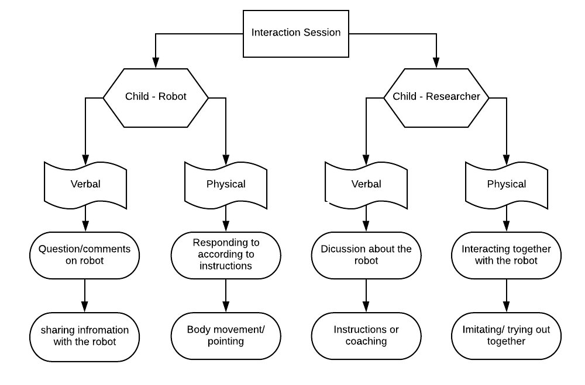
Observational Framework
Once all the questionnaires are collected, the data will be transferred onto a spreadsheet on Microsoft Excel. Patterns and trends will be identified, and responses will be calculated using simple statistics, such as percentages and bar charts, to display the results. Interviews will be audio-recorded and transcribed by the research team. The data will be summaries into relevant fragments based on the interview topic guide. To check and establish validity of the study, the study will triangulate the three methods used in this study.
11.0 ETHICAL AND REGULATORY CONSIDERATIONS

11.1 Assessment and management of risk

There are no particular or enhanced risks to paediatric patients taking part in this research project. If the paediatric patient is inconvenienced or distressed by the study then they will be reminded that they are free to withdraw from the study if they wish. Paediatric patients will be visiting the hospital due to being in distress or pain. This needs to be considered when they are interacting with the social robots. If a paediatric patient shows any distressing behaviour, such as crying, while interacting with social robots, the parent/carer will be reminded that they are free to withdraw. In order to avoid infection passing from one paediatric patient to another, the social robots will be cleaned using a soft damp cloth, and then dried with a soft dry cloth to remove humidity. Due to recent event with the coronavirus (COVID-19) the room will be thoroughly cleaned after each participant with disinfectant wipes.

11.2 Research Ethics Committee (REC) and other Regulatory review & report

This study will require ethical review and approval from the UK Health Departments Research Ethics Service, the NHS REC the Health Research Authority. These authorities will review the study protocol, informed consent forms, information sheets, posters and other relevant documents.

11.3 Amendments

If it is necessary for the protocol to be amended, the amendment and a new version of the study protocol will be approved by the REC. If new information becomes available, that may affect participant’s contribution or safety on the study, revised patient information sheets will be prepared and approved by the REC.

- PROJECT PLAN

Target dates for the study are given below

NHS Ethical approval  The University of Sheffield, School of Health and Related Research Ethical Approval | April 2020 – June 2020
Visit to the hospital with Robots | July 2020 – Oct 2020
Period of recruitment | July 2020 – Oct 2020
Data Collection | July 2020 – Oct 2020
Finial visits to the hospital | Oct 2020 – 2020
Transcription | Oct 2020 – Dec 2020
Data analysis | Oct 2020 – Dec 2020
Preparation of study report, abstracts and manuscript | Dec 2020 – Jan 2021

13.0 Public Involvement

A focus group with children age 8 to 12-year olds from a youth club in Parson Cross was conducted to discuss the information sheets as well as to examine their opinions of the layout and design of the documents. At the end of the focus group, the information sheet was deemed acceptable by some, and a few asked if a couple of words could be changed to more straightforward terms. We made the changes that were asked and updated the information sheet accordingly.

Reference

Alemi, M., Ghanbarzadeh, A., Meghdari, A. and Moghadam, L.J., 2016. Clinical application of a humanoid robot in pediatric cancer interventions. International Journal of Social Robotics, 8(5), pp.743-759.

Beran, T.N., Ramirez-Serrano, A., Vanderkooi, O.G. and Kuhn, S., 2015. Humanoid robotics in health care: An exploration of children’s and parents’ emotional reactions. Journal of health psychology, 20(7), pp.984-989.

Collins, E. C., Prescott, T. J., & Mitchinson, B. (2015, July). Saying it with light: A pilot study of affective communication using the MIRO robot. In Conference on Biomimetic and Biohybrid Systems (pp. 243-255). Springer, Cham.

Dawe, J., Sutherland, C., Barco, A. and Broadbent, E., 2019. Can social robots help children in healthcare contexts? A scoping review. BMJ paediatrics open, 3(1).

Heuvel, R. v. d., 2018. The next generation of play: Robots to support play in rehabilitation and special education for children with physical disabilities. Maastricht : Herlen .

Huijnen, C., 2018. A Touching Connection: Robot-mediated interventions for children with autism spectrum disorder. Maastricht: Maastricht Unversity .

Huijnen, C.A., Lexis, M.A. and de Witte, L.P., 2016. Matching robot KASPAR to autism spectrum disorder (ASD) therapy and educational goals. International Journal of Social Robotics, 8(4), pp.445-455.

Jeong, S., Logan, D.E., Goodwin, M.S., Graca, S., O'Connell, B., Goodenough, H., Anderson, L., Stenquist, N., Fitzpatrick, K., Zisook, M. and Plummer, L., 2015, March. A social robot to mitigate stress, anxiety, and pain in hospital pediatric care. In Proceedings of the Tenth Annual ACM/IEEE International Conference on Human-Robot Interaction Extended Abstracts(pp. 103-104). ACM.)

Jibb, L.A., Birnie, K.A., Nathan, P.C., Beran, T.N., Hum, V., Victor, J.C. and Stinson, J.N., 2018. Using the MEDiPORT humanoid robot to reduce procedural pain and distress in children with cancer: a pilot randomized controlled trial. Pediatric blood & cancer, 65(9), p.e27242.

Li, H.C.W. and Lam, H.Y.A., 2003. Paediatric day surgery: impact on Hong Kong Chinese children and their parents. Journal of clinical nursing, 12(6), pp.882-887.

Li, H.C.W. and Lopez, V., 2006. Assessing children's emotional responses to surgery: a multidimensional approach. Journal of advanced nursing, 53(5), pp.543-550.

Luyten, T., Braun, S., Van Hooren, S. and Witte, L.D., 2017. Participant responses to physical, open-ended interactive digital artworks: a systematic review. International Journal of Arts and Technology, 10(2), pp.94-134.

Luyten, T., Braun, S., Jamin, G., van Hooren, S. and de Witte, L., 2018. How nursing home residents with dementia respond to the interactive art installation ‘VENSTER’: a pilot study. Disability and Rehabilitation: Assistive Technology, 13(1), pp.87-94.

Okita, S.Y., 2013. Self–Other's Perspective Taking: The Use of Therapeutic Robot Companions as Social Agents for Reducing Pain and Anxiety in Pediatric Patients. Cyberpsychology, Behavior, and Social Networking, 16(6), pp.436-441.

Preece, J., Rogers, Y. & Sharp, H., 2002. Interaction Design: beyond human-computer interaction. United States of America : John Wiley & Sons Inc.

Price, P. C. et al., n.d. 10.2 SINGLE-SUBJECT RESEARCH DESIGNS. [Online]
Available at: https://opentext.wsu.edu/carriecuttler/chapter/10-2-single-subject-research-designs/

Tranquada, S., Chen, M. & Chisik, Y., 2013. Hospital Hero: a game for reducing stress and anxiety of hospitalised children in emergency room. s.l., International Conference on Advances in Computer Entertainment Technology: Springer, Cham.

